Netty 深入剖析

#### 一 netty简介

##### 1.1 业界使用netty的开源框架

* dubbo
* RocketMQ
* Spark
* ElasticSearch
* Cassandra 开源分布式nosql数据库
* Flink 分布式高性能高可用的流处理框架
* Netty-SocketIo socketIo协议的java服务端实现
* Spring5 使用netty作为http协议框架
* Grpc 谷歌开源的高性能Rpc框架
* 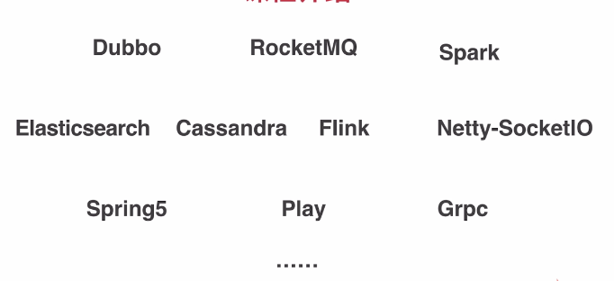

##### 1.2. Netty是什么？ 为什么使用netty之后，几乎不用担心性能问题

* 异步事件驱动框架，用于快速开发高性能服务端和客户端
* 封装了JDK底层BIO和NIO模型，提供高度可用的API（提供了非常多的扩展点，使API更加灵活丰富，channelHandler热插拔机制，解放了业务逻辑之外的细节问题，使业务逻辑的热添加和删除变得容易）
* 自带编解码器解决了拆包粘包问题，用户只用关心业务逻辑
* 精心设计的reactor线程模型支持高并发海量连接（为什么netty只使用了少量的线程，就能管理成千上万甚至几十万的连接）
* 自带各种协议栈让你处理任何一种通用协议都几乎不用亲自动手

##### 1.3. 为什么学netty

* 各大开源框架选择netty作为底层通信框架
* 更好的使用，少走弯路
* 单机连接数上不去？性能遇到瓶颈？如何调优
* 详解reactor线程模型，实践中举一反三
* 庞大的项目是如何组织的，设计模式，体验优秀的设计
* 阅读源码 -- 可以作为第一个深入研究的开源框架

##### 1.4. 目标

* 掌握netty底层核心原理，解决各类问题，深度调优
* 给netty官方提issue
* 实现一个简易版的netty
* 开启阅读源码之旅
* 加速掌握基于netty的各类中间件

##### 1.5. 技术储备

* java基础，多线程
* TCP原理， NIO

#### 二 netty基本组件

包括：NioEventLoop（发动机：起了两种类型的线程），Channel（对连接的封装，数据读写），ByteBuf（数据流），Pipeline（逻辑处理链），ChannelHandler（逻辑）

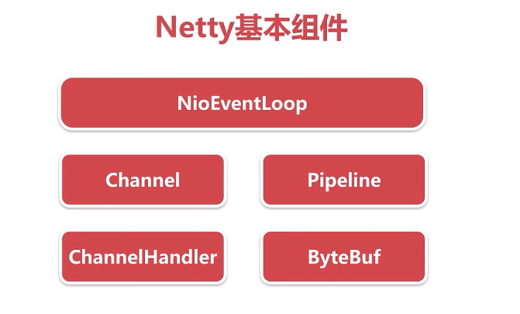

##### 2.1 不使用netty情况下，模拟传统的客户端与服务端通信

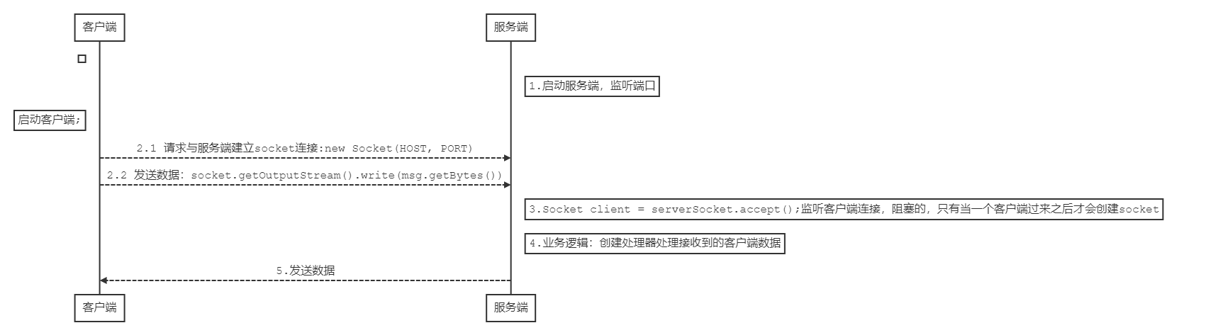

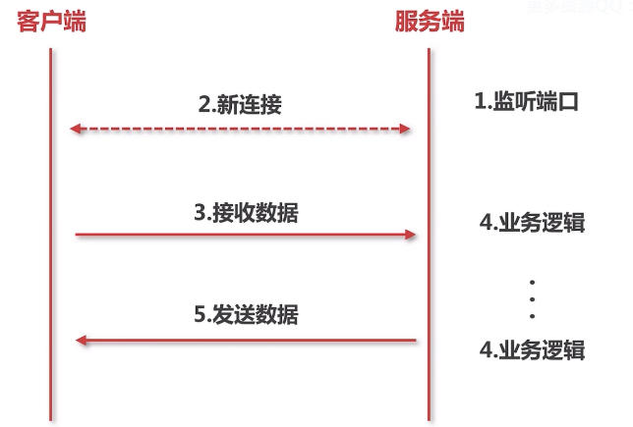

###### 2.1.1 监听端口实际包含两层含义：对应两个while循环

a）server不断的在某个端口上监听新用户的连接

b）新用户的连接建立完成后，在对应的端口上不断的监听新连接的数据

netty实现：

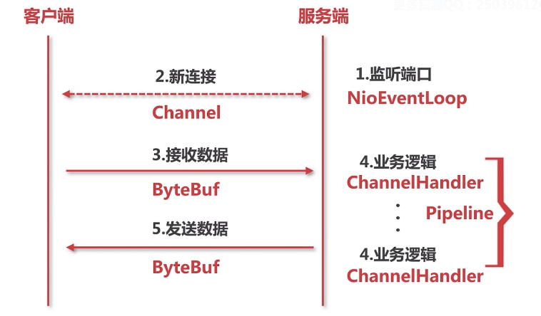

##### 2.2 netty - NioEventLoop

**对应socket编程的线程**

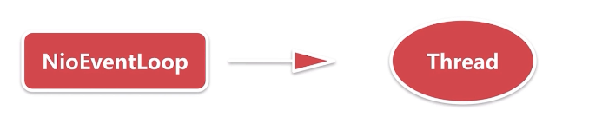

NioEventLoop ：nio事件循环

###### 2.2.1 新连接的接入

###### 2.2.2 当前存在的连接上数据流的读写

##### 2.3 netty - channel

channel 定义：  
* A nexus to a network socket or a component which is capable of I/O  
* operations such as read, write, connect, and bind.

**对应socket编程的socket**

**端口上监听到的新用户的连接**

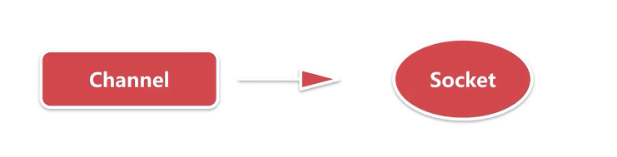

io.netty.channel.nio.AbstractNioMessageChannel#doReadMessages

SocketChannel ch = javaChannel().accept();

java IO编程模型 -- 当作socket处理

NIO编程模型 -- socketChannel

netty -- 封装成自定义的channel

基于channel，一系列的读写都可以在这个连接上操作，其实就是对socket的抽象

##### 2.4 netty - ByteBuf

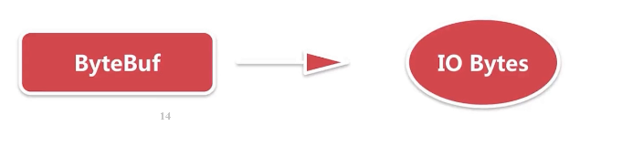

**服务端接受用户的数据流的载体都是基于ByteBuf，封装了很多api可以与底层的连接的数据流通信**

##### 2.5 netty - channelHandler

**服务端处理业务逻辑的处理器**

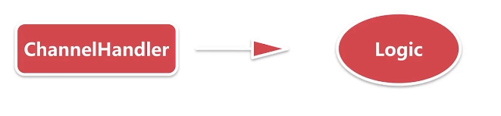

io.netty.channel.DefaultChannelPipeline#addFirst(io.netty.channel.ChannelHandler...)

通过ChannelPipeline可以动态的添加channelHandler

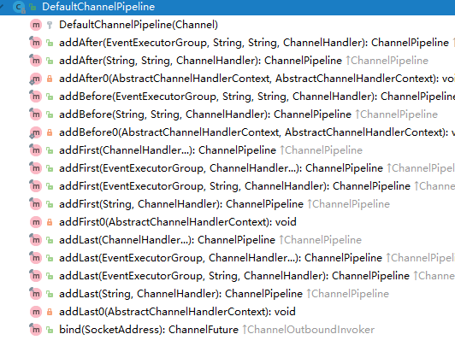

@Override  
public final ChannelPipeline addFirst(ChannelHandler... handlers) {  
 return addFirst(null, handlers);  
}

实际生产环境下，客户端与服务端的通信的时候都很复杂，

一般都需要定义二进制的协议，对二进制协议的数据进行数据包的拆分，对不同类型的协议数据包转换成不同的java对象并作不同的处理。

netty把每一个处理过程都当作ChannelHandler。

将不同的处理过程交给不同的channelHandler处理。

用户可以自定义channelHandler。

例如：数据包分包器

##### 2.6 netty - Pipeline - 逻辑链

netty什么时候将Pipeline加入到每一个客户端连接的处理过程的。

protected AbstractChannel(Channel parent, ChannelId id) {  
 this.parent = parent;  
 this.id = id;  
 unsafe = newUnsafe();  
 pipeline = newChannelPipeline();  
}

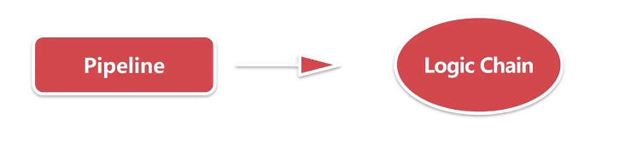

#### 三. netty服务端启动

public final class Server {  
 public static void main(String[] args) {  
 // bossGroup 对应 socket编程中 server端 的 线程  
 EventLoopGroup bossGroup = new NioEventLoopGroup(1);  
 // workGroup 对应 socket编程中 client端 的 线程  
 EventLoopGroup workGroup = new NioEventLoopGroup();  
  
 ServerBootstrap bootstrap = new ServerBootstrap();  
  
 bootstrap.group(bossGroup, workGroup)  
 .channel(NioServerSocketChannel.class)  
 .childOption(ChannelOption.TCP_NODELAY, true)  
 .childAttr(AttributeKey.newInstance("childAttr"), "childAttrValue")  
 .handler(new ServerHandler())  
 .childHandler(new ChannelInitializer<SocketChannel>() {  
  
 @Override  
 protected void initChannel(SocketChannel ch) throws Exception {  
 ch.pipeline().addLast();  
 }  
 });  
 try {  
 //服务端创建的入口 bind()  
 ChannelFuture channelFuture = bootstrap.bind(8888).sync();  
 channelFuture.channel().closeFuture().sync();  
 } catch (InterruptedException e) {  
 e.printStackTrace();  
 }  
 }  
}

##### 3.1 思考：服务端的socket在哪里初始化？在哪里accept连接？

##### 3.2 netty服务端启动的四个过程

###### 3.2.1 创建服务端channel

ChannelFuture channelFuture = bootstrap.bind(8888).sync();

private ChannelFuture doBind(final SocketAddress localAddress) {  
 final ChannelFuture regFuture = initAndRegister();  
 final Channel channel = regFuture.channel();  
 ....  
}

final ChannelFuture initAndRegister() {  
 Channel channel = null;  
 try {  
 channel = channelFactory.newChannel();//创建服务端channel  
 init(channel);//初始化服务端channel  
 } catch (Throwable t) {  
 .....  
}

@Override  
public T newChannel() {  
 try {  
 // 这里的clazz指什么？ --> NioServerSocketChannel.class  
 return clazz.newInstance();//反射  
 } catch (Throwable t) {  
 throw new ChannelException("Unable to create Channel from class " + clazz, t);  
 }  
}

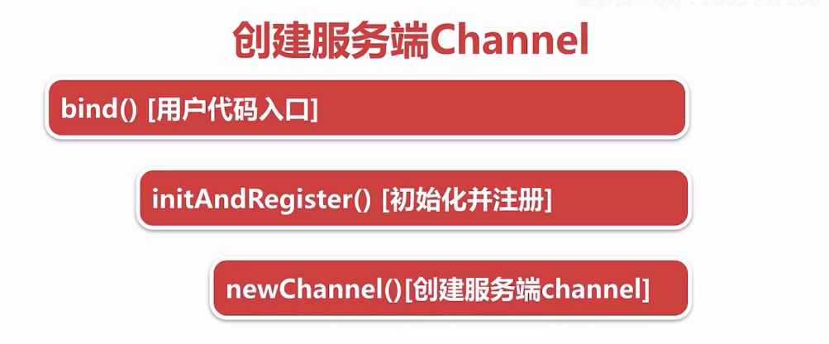

NioServerSocketChannel**如何构造的

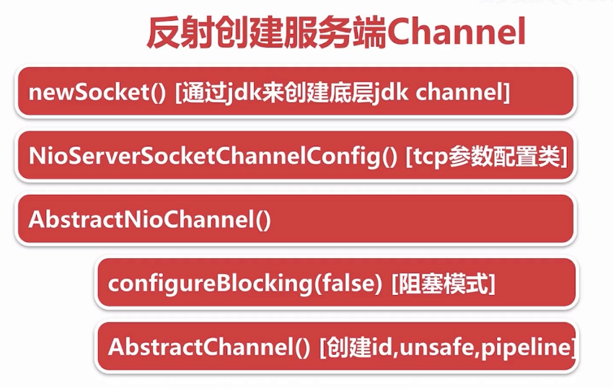

io.netty.channel.socket.nio.NioServerSocketChannel#NioServerSocketChannel()  
public NioServerSocketChannel() {  
 this(newSocket(DEFAULT_SELECTOR_PROVIDER));  
}

io.netty.channel.socket.nio.NioServerSocketChannel#NioServerSocketChannel(java.nio.channels.ServerSocketChannel)  
   
public NioServerSocketChannel(ServerSocketChannel channel) {  
 super(null, channel, SelectionKey.OP_ACCEPT);  
 config = new NioServerSocketChannelConfig(this, javaChannel().socket());  
}

io.netty.channel.nio.AbstractNioChannel#AbstractNioChannel  
protected AbstractNioChannel(Channel parent, SelectableChannel ch, int readInterestOp) {  
 super(parent);  
 this.ch = ch;  
 this.readInterestOp = readInterestOp;  
 try {  
 ch.configureBlocking(false);  
 } catch (IOException e) {  
 ...  
 }  
}

io.netty.channel.AbstractChannel#AbstractChannel(io.netty.channel.Channel)  
protected AbstractChannel(Channel parent) {  
 this.parent = parent;  
 id = newId();  
 unsafe = newUnsafe();  
 pipeline = newChannelPipeline();  
}

###### 3.2.2 初始化服务端channel

* io.netty.bootstrap.AbstractBootstrap#init() 初始化入口
  + set ChannelOptions， ChannelAttrs
  + set ChildOptions，ChildAttrs
  + config handler [配置服务端Pipeline]
  + add ServerBootStrapAcceptor[添加连接接入器]

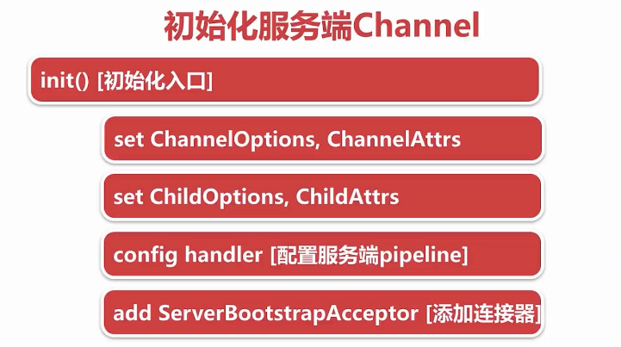

---》保存用户自定义的属性

---》ServerBootstrapAcceptor 创建新连接接入器（一个特殊的channelHandler）

---》将用户自定义的属性传到新连接接入器中，当accept到一个新连接，通过这几个属性对新的连接进行配置，就可以把一个新的连接绑定到一个新的线程上去。

@Override  
void init(Channel channel) throws Exception {  
 final Map<ChannelOption<?>, Object> options = options0();  
 synchronized (options) {  
 channel.config().setOptions(options);  
 }  
  
 final Map<AttributeKey<?>, Object> attrs = attrs0();  
 synchronized (attrs) {  
 for (Entry<AttributeKey<?>, Object> e: attrs.entrySet()) {  
 @SuppressWarnings("unchecked")  
 AttributeKey<Object> key = (AttributeKey<Object>) e.getKey();  
 channel.attr(key).set(e.getValue());  
 }  
 }  
  
 ChannelPipeline p = channel.pipeline();  
  
 final EventLoopGroup currentChildGroup = childGroup;  
 final ChannelHandler currentChildHandler = childHandler;  
 final Entry<ChannelOption<?>, Object>[] currentChildOptions;  
 final Entry<AttributeKey<?>, Object>[] currentChildAttrs;  
 synchronized (childOptions) {  
 currentChildOptions = childOptions.entrySet().toArray(newOptionArray(childOptions.size()));  
 }  
 synchronized (childAttrs) {  
 currentChildAttrs = childAttrs.entrySet().toArray(newAttrArray(childAttrs.size()));  
 }  
  
 p.addLast(new ChannelInitializer<Channel>() {  
 @Override  
 public void initChannel(Channel ch) throws Exception {  
 final ChannelPipeline pipeline = ch.pipeline();  
 ChannelHandler handler = config.handler();  
 if (handler != null) {  
 pipeline.addLast(handler);  
 }  
 ch.eventLoop().execute(new Runnable() {  
 @Override  
 public void run() {  
 pipeline.addLast(new ServerBootstrapAcceptor(  
 currentChildGroup, currentChildHandler, currentChildOptions, currentChildAttrs));  
 }  
 });  
 }  
 });  
}

###### 3.2.3 将channel注册到事件轮询器selector

* io.netty.channel.AbstractChannel.AbstractUnsafe#register（channel）[入口]
* this.eventLoop = eventLoop [绑定线程]
* io.netty.channel.AbstractChannel.AbstractUnsafe#register0 [实际注册]
  + io.netty.channel.AbstractChannel#doRegister [调用底层JDK底层注册]
  + io.netty.channel.DefaultChannelPipeline#invokeHandlerAddedIfNeeded [添加channelHandler的时候触发用户回调]
  + io.netty.channel.DefaultChannelPipeline#fireChannelActive [传播channel注册成功事件到用户代码方法]

#ChannelFuture regFuture = config().group().register(channel);  
  
@Override  
 public final void register(EventLoop eventLoop, final ChannelPromise promise) {  
 if (eventLoop == null) {  
 throw new NullPointerException("eventLoop");  
 }  
 if (isRegistered()) {  
 promise.setFailure(new IllegalStateException("registered to an event loop already"));  
 return;  
 }  
 if (!isCompatible(eventLoop)) {  
 promise.setFailure(  
 new IllegalStateException("incompatible event loop type: " + eventLoop.getClass().getName()));  
 return;  
 }  
 // 处理所有I/O事件  
 AbstractChannel.this.eventLoop = eventLoop;  
 if (eventLoop.inEventLoop()) {  
 register0(promise);  
 } else {  
 try {  
 eventLoop.execute(new Runnable() {  
 @Override  
 public void run() {  
 register0(promise);  
 }  
 });  
 } catch (Throwable t) {  
 logger.warn(  
 "Force-closing a channel whose registration task was not accepted by an event loop: {}",  
 AbstractChannel.this, t);  
 closeForcibly();  
 closeFuture.setClosed();  
 safeSetFailure(promise, t);  
 }  
 }  
 }

private void register0(ChannelPromise promise) {  
 try {  
 // check if the channel is still open as it could be closed in the mean time when the register  
 // call was outside of the eventLoop  
 if (!promise.setUncancellable() || !ensureOpen(promise)) {  
 return;  
 }  
 boolean firstRegistration = neverRegistered;  
 doRegister();  
 neverRegistered = false;  
 registered = true;  
  
 // Ensure we call handlerAdded(...) before we actually notify the promise. This is needed as the  
 // user may already fire events through the pipeline in the ChannelFutureListener.  
 pipeline.invokeHandlerAddedIfNeeded();  
  
 safeSetSuccess(promise);  
 pipeline.fireChannelRegistered();  
 // Only fire a channelActive if the channel has never been registered. This prevents firing  
 // multiple channel actives if the channel is deregistered and re-registered.  
 if (isActive()) {  
 if (firstRegistration) {  
 pipeline.fireChannelActive();  
 } else if (config().isAutoRead()) {  
 // This channel was registered before and autoRead() is set. This means we need to begin read  
 // again so that we process inbound data.  
 //  
 // See https://github.com/netty/netty/issues/4805  
 beginRead();  
 }  
 }  
 } catch (Throwable t) {  
 // Close the channel directly to avoid FD leak.  
 closeForcibly();  
 closeFuture.setClosed();  
 safeSetFailure(promise, t);  
 }  
}

io.netty.channel.nio.AbstractNioChannel#doRegister

@Override  
protected void doRegister() throws Exception {  
 boolean selected = false;  
 for (;;) {  
 try {  
 //调用jdk底层的注册方法 this代表 NioServerSocketChannel.class  
 //将NioServerSocketChannel作为一个attachment传到jdk底层的channel  
 selectionKey = javaChannel().register(eventLoop().selector, 0, this);  
 return;  
 } catch (CancelledKeyException e) {  
 if (!selected) {  
 eventLoop().selectNow();  
 selected = true;  
 } else {  
 // We forced a select operation on the selector before but the SelectionKey is still cached  
 // for whatever reason. JDK bug ?  
 throw e;  
 }  
 }  
 }  
}

java.nio.channels.SelectableChannel#register(java.nio.channels.Selector, int, java.lang.Object)

* @param sel  
* The selector with which this channel is to be registered  
* @param ops  
* The interest set for the resulting key  
* @param att  
* The attachment for the resulting key; may be <tt>null</tt>  
 public abstract SelectionKey register(Selector sel, int ops, Object att)  
 throws ClosedChannelException;

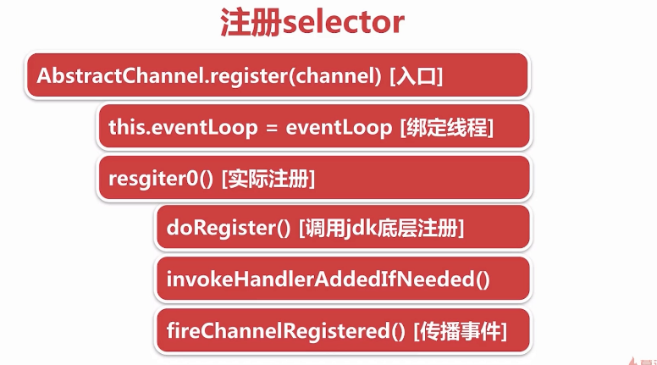

###### 3.2.4 端口绑定

###### fig:

* io.netty.channel.AbstractChannel.AbstractUnsafe#bind [入口]
* io.netty.channel.AbstractChannel#doBind

@Override  
public final void bind(final SocketAddress localAddress, final ChannelPromise promise) {  
 assertEventLoop();  
  
 if (!promise.setUncancellable() || !ensureOpen(promise)) {  
 return;  
 }  
 if (Boolean.TRUE.equals(config().getOption(ChannelOption.SO_BROADCAST)) &&  
 localAddress instanceof InetSocketAddress &&  
 !((InetSocketAddress) localAddress).getAddress().isAnyLocalAddress() &&  
 !PlatformDependent.isWindows() && !PlatformDependent.isRoot()) {  
 logger.warn(  
 "A non-root user can't receive a broadcast packet if the socket " +  
 "is not bound to a wildcard address; binding to a non-wildcard " +  
 "address (" + localAddress + ") anyway as requested.");  
 }  
 //端口绑定之前是false，doBind之后变为true  
 boolean wasActive = isActive();  
 try {  
   
 doBind(localAddress);  
   
 } catch (Throwable t) {  
 safeSetFailure(promise, t);  
 closeIfClosed();  
 return;  
 }  
  
 //端口绑定之前不是active，绑定之后编程active  
 if (!wasActive && isActive()) {  
 invokeLater(new Runnable() {  
 @Override  
 public void run() {  
 //传播事件  
 pipeline.fireChannelActive();  
 }  
 });  
 }  
  
 safeSetSuccess(promise);  
}

io.netty.channel.socket.nio.NioServerSocketChannel#doBind

@Override  
protected void doBind(SocketAddress localAddress) throws Exception {  
 if (PlatformDependent.javaVersion() >= 7) {  
 //调用java底层api  
 javaChannel().bind(localAddress, config.getBacklog());  
 } else {  
 javaChannel().socket().bind(localAddress, config.getBacklog());  
 }  
}

io.netty.channel.DefaultChannelPipeline.HeadContext#channelActive

@Override  
public void channelActive(ChannelHandlerContext ctx) throws Exception {  
 ctx.fireChannelActive();  
  
 readIfIsAutoRead();  
}

io.netty.channel.DefaultChannelPipeline.HeadContext#readIfIsAutoRead

private void readIfIsAutoRead() {  
 if (channel.config().isAutoRead()) {  
 channel.read();  
 }  
}

io.netty.channel.AbstractChannel#read

@Override  
public Channel read() {  
 pipeline.read();  
 return this;  
}

io.netty.channel.AbstractChannelHandlerContext#read

@Override  
public ChannelHandlerContext read() {  
 final AbstractChannelHandlerContext next = findContextOutbound();  
 EventExecutor executor = next.executor();  
 if (executor.inEventLoop()) {  
 next.invokeRead();  
 } else {  
 Runnable task = next.invokeReadTask;  
 if (task == null) {  
 next.invokeReadTask = task = new Runnable() {  
 @Override  
 public void run() {  
 next.invokeRead();  
 }  
 };  
 }  
 executor.execute(task);  
 }  
  
 return this;  
}

io.netty.channel.DefaultChannelPipeline.HeadContext#read

@Override  
public void read(ChannelHandlerContext ctx) {  
 unsafe.beginRead();  
}

io.netty.channel.AbstractChannel.AbstractUnsafe#beginRead

@Override  
public final void beginRead() {  
 assertEventLoop();  
  
 if (!isActive()) {  
 return;  
 }  
 try {  
 doBeginRead();  
 } catch (final Exception e) {  
 invokeLater(new Runnable() {  
 @Override  
 public void run() {  
 pipeline.fireExceptionCaught(e);  
 }  
 });  
 close(voidPromise());  
 }  
}

io.netty.channel.nio.AbstractNioChannel#doBeginRead

@Override  
protected void doBeginRead() throws Exception {  
 // Channel.read() or ChannelHandlerContext.read() was called  
 //channel注册到selector上后返回的key，key对应channel  
 final SelectionKey selectionKey = this.selectionKey;  
 if (!selectionKey.isValid()) {  
 return;  
 }  
  
 readPending = true;  
  
 //Retrieves this key's interest set  
 final int interestOps = selectionKey.interestOps();  
 //与运算  
 if ((interestOps & readInterestOp) == 0) {  
 //将2者进行或运算以后重新注册到selectionKey上 即在之前事件的基础上再增加一个事件  
 //readInterestOp 其实是NioServerSocketChannel的构造函数传进来的SelectionKey.OP_ACCEPT  
 //是个accept事件  
 selectionKey.interestOps(interestOps | readInterestOp);  
 }  
}

小结：

---》端口绑定bind

---》触发active事件

---》服务端channe doBeginRead方法, 向selector注册accept事件，这样netty就可以接收新的连接

tip:

与(&)运算： 同为 1 才为1

5 二进制 101  
3 二进制 011  
 结果 001

或(|)运算：有一个为1，则为1

5 二进制 101  
3 二进制 011  
 结果 111

异或(^)运算：不相同则为 1

5 二进制 101  
3 二进制 011  
 结果 110

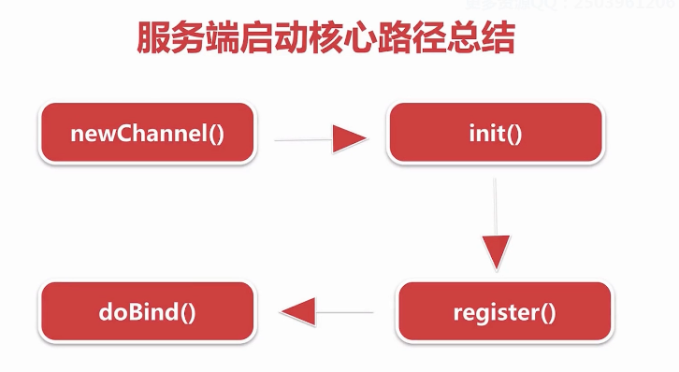

#### 四、NioEventLoop

##### 4.1 思考三个问题

* 默认情况下，Netty服务端起多少线程？何时启动？
  + 2*cpu 调用execute方法时，判断当前线程是EventLoop线程，若是说明线程已启动，若是外部线程，则会调用startThread方法，判断当前线程是否启动，没有则启动当前线程。
* Netty如何解决JDK空轮询bug，避免cpu飙高的？
* 超过512次，重新创建selector，并把原selector的所有的key移交到新的select or
* Netty如何保证异步串行无锁化？
* netty通过inEventLoop方法判断是外部线程，将所有操作封装成一个task丢到MpscQueue中，挨个执行。
  + 拿到客户端的一个channel，不需要对这个channel同步就可以进行多线程并发读写。
  + channelHandler中的所有操作都是线程安全的，不需要进行同步

##### 4.2 NioEventLoop创建

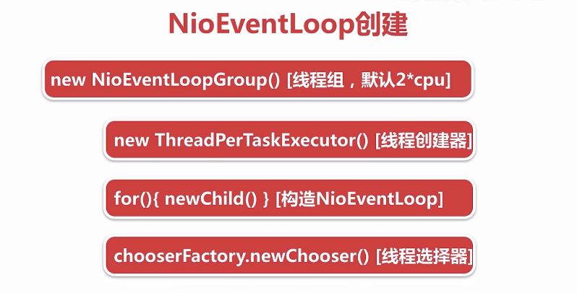

* new NioEventLoopGroup(1) [线程组，默认 2*CPU] ：若不传构造参数，默认创建2倍cpu核心数的NioEventLoopGroup
* protected MultithreadEventLoopGroup(int nThreads, Executor executor, Object... args) {  
   super(nThreads == 0 ? DEFAULT_EVENT_LOOP_THREADS : nThreads, executor, args);  
  }
* new ThreadPerTaskExecutor(newDefaultThreadFactory()) [线程创建器]：负责创建NioEventLoop底层对应的线程
  + 每次执行任务都会创建一个线程 : netty自己封装的FastThreadLocalThread，并非原生的线程。
  + NioEventLoop线程命名规则 nioEventLoop-1-xx
* for(){ new Child() } [构造NioEventLoop]
  + 保存线程执行器 ThreadPerTaskExecutor
  + 创建一个MpscQueue
  + io.netty.channel.nio.NioEventLoopGroup#newChild
  + @Override  
    protected EventLoop newChild(Executor executor, Object... args) throws Exception {  
     return new NioEventLoop(this, executor, (SelectorProvider) args[0],  
     ((SelectStrategyFactory) args[1]).newSelectStrategy(), (RejectedExecutionHandler) args[2]);  
    }
  + protected SingleThreadEventLoop(EventLoopGroup parent, Executor executor,  
     boolean addTaskWakesUp, int maxPendingTasks,  
     RejectedExecutionHandler rejectedExecutionHandler) {  
     super(parent, executor, addTaskWakesUp, maxPendingTasks, rejectedExecutionHandler);  
     tailTasks = newTaskQueue(maxPendingTasks);  
    }
  + io.netty.channel.nio.NioEventLoop#newTaskQueue
  + @Override  
    protected Queue<Runnable> newTaskQueue(int maxPendingTasks) {  
     // This event loop never calls takeTask()  
     //Mpsc MUltiply producer（外部线程） single consumer（NioEventLoop线程）   
     return PlatformDependent.newMpscQueue(maxPendingTasks);  
    }
  + /**  
     * Create a new {@link Queue} which is safe to use for multiple producers (different threads) and a single  
     * consumer (one thread!).  
     */  
    public static <T> Queue<T> newMpscQueue(final int maxCapacity) {  
     return Mpsc.newMpscQueue(maxCapacity);  
    }
  + 创建一个selector
  + NioEventLoop(NioEventLoopGroup parent, Executor executor, SelectorProvider selectorProvider,  
     SelectStrategy strategy, RejectedExecutionHandler rejectedExecutionHandler) {  
     super(parent, executor, false, DEFAULT_MAX_PENDING_TASKS, rejectedExecutionHandler);  
     if (selectorProvider == null) {  
     throw new NullPointerException("selectorProvider");  
     }  
     if (strategy == null) {  
     throw new NullPointerException("selectStrategy");  
     }  
     provider = selectorProvider;  
     //一个selector和一个NioEventLoop绑定  
     selector = openSelector();  
     selectStrategy = strategy;  
    }
* chooserFactory.newChooser(children) [线程选择器]：为每一个新连接，分配NioEventLoop线程
* io.netty.util.concurrent.MultithreadEventExecutorGroup#next
* 第1个连接进来的时候选择第1个nioEventLoop进行绑定
* .....
* 第n个连接进来的时候选择第n个nioEventLoop进行绑定
* 第n+1个连接进来的时候选择第1个nioEventLoop进行绑定,循环进行

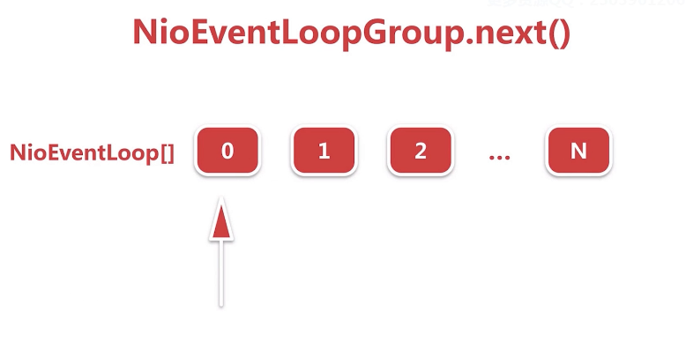

**netty经过优化：**与运算实现循环取数组下标，要比取模运算高效的多,因为在计算机底层，与运算是二进制的运算。

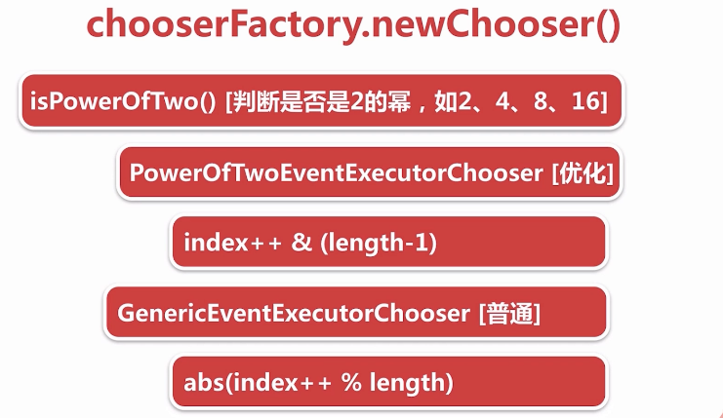

public EventExecutorChooser newChooser(EventExecutor[] executors) {  
 if (isPowerOfTwo(executors.length)) {  
 return new PowerOfTowEventExecutorChooser(executors);  
 } else {  
 return new GenericEventExecutorChooser(executors);  
 }  
}

io.netty.util.concurrent.DefaultEventExecutorChooserFactory.GenericEventExecutorChooser#next

@Override  
 public EventExecutor next() {  
 return executors[Math.abs(idx.getAndIncrement() % executors.length)];  
 }

io.netty.util.concurrent.DefaultEventExecutorChooserFactory.PowerOfTowEventExecutorChooser#next

public EventExecutor next() {  
 return executors[idx.getAndIncrement() & executors.length - 1];  
}

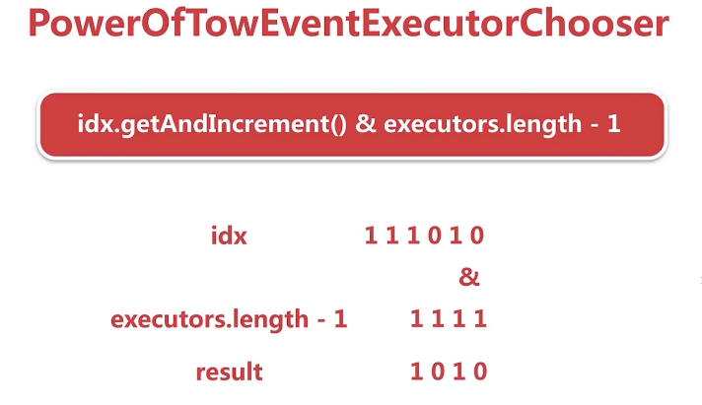

##### 4.3 NioEventLoop启动流程

NioEventLoop启动两大触发器：

* 服务端启动绑定端口
  + 服务端将具体绑定端口的操作封装成一个task，调用NioEventLoop的execute方法
  + netty判断调用execute方法的线程是否是Nio线程，若不是，调用startThread()方法尝试创建线程。
  + 通过线程执行器 ThreadPerTaskExecutor创建nio线程 - FastThreadLocalThread
  + NioEventLoop对象会将创建的线程保存，目的是为了：判断后续对NioEventLoop相关的执行线程是否是本身，若不是，就封装成一个task，扔到一个taskQueue中串行执行，保证线程安全
  + 调用驱动NioEventLoop运转的核心方法：run()
* 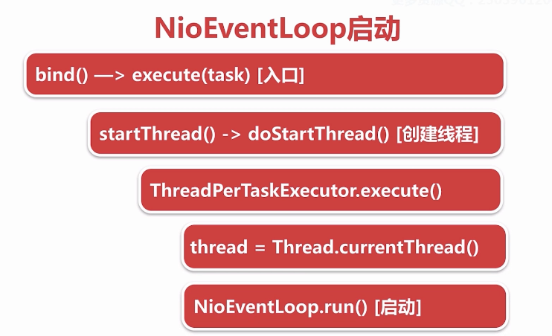
* io.netty.bootstrap.AbstractBootstrap#doBind0  
  private static void doBind0(  
   ......  
   channel.eventLoop().execute(new Runnable() {  
   @Override  
   public void run() {  
   if (regFuture.isSuccess()) {  
   channel.bind(localAddress, promise).addListener(ChannelFutureListener.CLOSE_ON_FAILURE);  
   } else {  
   promise.setFailure(regFuture.cause());  
   }  
   }  
   });
* io.netty.util.concurrent.SingleThreadEventExecutor#execute  
  @Override  
  public void execute(Runnable task) {  
   if (task == null) {  
   throw new NullPointerException("task");  
   }  
   boolean inEventLoop = inEventLoop();  
   if (inEventLoop) {  
   addTask(task);  
   } else {  
   startThread();  
   addTask(task);  
   if (isShutdown() && removeTask(task)) {  
   reject();  
   }  
   }  
   if (!addTaskWakesUp && wakesUpForTask(task)) {  
   wakeup(inEventLoop);  
   }  
  }
* io.netty.util.concurrent.AbstractEventExecutor#inEventLoop  
  判断线程是否是EventLoop线程  
  @Override  
  public boolean inEventLoop() {  
   return inEventLoop(Thread.currentThread());  
  }
* io.netty.util.concurrent.SingleThreadEventExecutor#inEventLoop  
  io.netty.util.concurrent.SingleThreadEventExecutor#thread  
    
  private volatile Thread thread;  
  @Override  
  public boolean inEventLoop(Thread thread) {  
   return thread == this.thread;  
  }
* private void startThread() {  
   if (STATE_UPDATER.get(this) == ST_NOT_STARTED) {  
   if (STATE_UPDATER.compareAndSet(this, ST_NOT_STARTED, ST_STARTED)) {  
   doStartThread();  
   }  
   }  
  }
* private void doStartThread() {  
   assert thread == null;  
   executor.execute(new Runnable() {  
   @Override  
   public void run() {  
   thread = Thread.currentThread();  
   if (interrupted) {  
   thread.interrupt();  
   }  
    
   boolean success = false;  
   updateLastExecutionTime();  
   try {  
   SingleThreadEventExecutor.this.run();  
   success = true;  
   } catch (Throwable t) {  
   logger.warn("Unexpected exception from an event executor: ", t);  
   } finally {  
   for (;;) {  
   int oldState = STATE_UPDATER.get(SingleThreadEventExecutor.this);  
   if (oldState >= ST_SHUTTING_DOWN || STATE_UPDATER.compareAndSet(  
   SingleThreadEventExecutor.this, oldState, ST_SHUTTING_DOWN)) {  
   break;  
   }  
   }  
    
   // Check if confirmShutdown() was called at the end of the loop.  
   if (success && gracefulShutdownStartTime == 0) {  
   logger.error("Buggy " + EventExecutor.class.getSimpleName() + " implementation; " +  
   SingleThreadEventExecutor.class.getSimpleName() + ".confirmShutdown() must be called " +  
   "before run() implementation terminates.");  
   }  
    
   try {  
   // Run all remaining tasks and shutdown hooks.  
   for (;;) {  
   if (confirmShutdown()) {  
   break;  
   }  
   }  
   } finally {  
   try {  
   cleanup();  
   } finally {  
   STATE_UPDATER.set(SingleThreadEventExecutor.this, ST_TERMINATED);  
   threadLock.release();  
   if (!taskQueue.isEmpty()) {  
   logger.warn(  
   "An event executor terminated with " +  
   "non-empty task queue (" + taskQueue.size() + ')');  
   }  
    
   terminationFuture.setSuccess(null);  
   }  
   }  
   }  
   }  
   });  
  }

#### 4.4 NioEventLoop执行逻辑 （底层干了哪些事情，如何保证高效运转）

* 
* 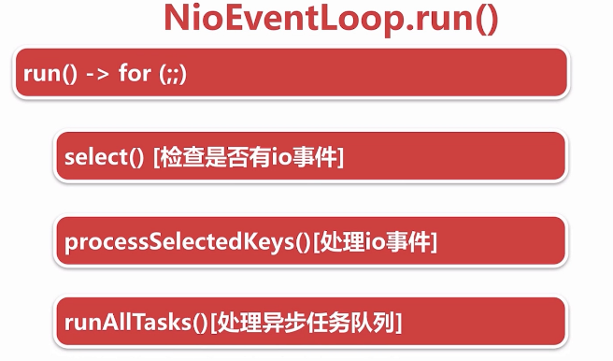
* NioEventLoop 执行逻辑：
* for循环体做三件事情：
* ---》调用select方法轮询注册到selector上的连接的i/o事件
* ---》调用processSelectedKeys()处理轮询出来的i/o事件
* ---》调用runAllTasks()方法处理外部线程扔到taskQueue中的任务
* @Override  
  protected void run() {  
   for (;;) {  
   try {  
   switch (selectStrategy.calculateStrategy(selectNowSupplier, hasTasks())) {  
   case SelectStrategy.CONTINUE:  
   continue;  
   case SelectStrategy.SELECT:  
   select(wakenUp.getAndSet(false));  
   if (wakenUp.get()) {  
   selector.wakeup();  
   }  
   default:  
   // fallthrough  
   }  
    
   cancelledKeys = 0;  
   needsToSelectAgain = false;  
   //默认50，处理i/o事件和运行任务时间是1 ：1  
   final int ioRatio = this.ioRatio;  
   if (ioRatio == 100) {  
   try {  
   processSelectedKeys();  
   } finally {  
   // Ensure we always run tasks.  
   runAllTasks();  
   }  
   } else {  
   final long ioStartTime = System.nanoTime();  
   try {  
   processSelectedKeys();  
   } finally {  
   // Ensure we always run tasks.  
   final long ioTime = System.nanoTime() - ioStartTime;  
   runAllTasks(ioTime * (100 - ioRatio) / ioRatio);  
   }  
   }  
   } catch (Throwable t) {  
   handleLoopException(t);  
   }  
   // Always handle shutdown even if the loop processing threw an exception.  
   try {  
   if (isShuttingDown()) {  
   closeAll();  
   if (confirmShutdown()) {  
   return;  
   }  
   }  
   } catch (Throwable t) {  
   handleLoopException(t);  
   }  
   }  
  }
  + **检测i/o事件，select方法执行逻辑**
    - deadline及任务穿插逻辑处理
      * select操作进行deadline处理，判断如果当前有任务在taskQueue里面就终止本次select操作
    - 阻塞式select
      * 如果没有到截止时间并且taskQueue没有任务，就进行阻塞式select操作
    - 避免jdk空轮询bug
      * 阻塞式select操作结束之后，判断这次select操作是否真的阻塞这么长时间，如果没有阻塞这么长时间，则表示可能触发了jdk nio空轮询的bug，接下来netty判断触发空轮询次数是否达到一定的阈值（512），如果达到阈值，就通过替换原来select操作的方式，巧妙的避开了空轮询的bug
  + io.netty.channel.nio.NioEventLoop#select
  + private void select(boolean oldWakenUp) throws IOException {  
     Selector selector = this.selector;  
     try {  
     int selectCnt = 0;  
     long currentTimeNanos = System.nanoTime();  
     long selectDeadLineNanos = currentTimeNanos + delayNanos(currentTimeNanos);  
     for (;;) {  
     long timeoutMillis = (selectDeadLineNanos - currentTimeNanos + 500000L) / 1000000L;  
     if (timeoutMillis <= 0) {  
     if (selectCnt == 0) {  
     selector.selectNow();  
     selectCnt = 1;  
     }  
     break;  
     }  
     if (hasTasks() && wakenUp.compareAndSet(false, true)) {  
     selector.selectNow();  
     selectCnt = 1;  
     break;  
     }  
     int selectedKeys = selector.select(timeoutMillis);  
     selectCnt ++;  
      
     if (selectedKeys != 0 || oldWakenUp || wakenUp.get() || hasTasks() || hasScheduledTasks()) {  
     break;  
     }  
     if (Thread.interrupted()) {  
     if (logger.isDebugEnabled()) {  
     logger.debug("Selector.select() returned prematurely because " +  
     "Thread.currentThread().interrupt() was called. Use " +  
     "NioEventLoop.shutdownGracefully() to shutdown the NioEventLoop.");  
     }  
     selectCnt = 1;  
     break;  
     }  
      
     long time = System.nanoTime();  
     if (time - TimeUnit.MILLISECONDS.toNanos(timeoutMillis) >= currentTimeNanos) {  
     // timeoutMillis elapsed without anything selected.  
     selectCnt = 1;  
     } else if (SELECTOR_AUTO_REBUILD_THRESHOLD > 0 &&  
     selectCnt >= SELECTOR_AUTO_REBUILD_THRESHOLD) {  
     logger.warn(  
     "Selector.select() returned prematurely {} times in a row; rebuilding Selector {}.",  
     selectCnt, selector);  
      
     rebuildSelector();  
     selector = this.selector;  
     // Select again to populate selectedKeys.  
     selector.selectNow();  
     selectCnt = 1;  
     break;  
     }  
     currentTimeNanos = time;  
     }  
      
     if (selectCnt > MIN_PREMATURE_SELECTOR_RETURNS) {  
     if (logger.isDebugEnabled()) {  
     logger.debug("Selector.select() returned prematurely {} times in a row for Selector {}.",  
     selectCnt - 1, selector);  
     }  
     }  
     } catch (CancelledKeyException e) {  
     if (logger.isDebugEnabled()) {  
     logger.debug(CancelledKeyException.class.getSimpleName() + " raised by a Selector {} - JDK bug?",  
     selector, e);  
     }  
     }  
    }
  + io.netty.channel.nio.NioEventLoop#rebuildSelector
  + public void rebuildSelector() {  
     if (!inEventLoop()) {  
     execute(new Runnable() {  
     @Override  
     public void run() {  
     rebuildSelector();  
     }  
     });  
     return;  
     }  
      
     final Selector oldSelector = selector;  
     final Selector newSelector;  
      
     if (oldSelector == null) {  
     return;  
     }  
      
     try {  
     newSelector = openSelector();  
     } catch (Exception e) {  
     logger.warn("Failed to create a new Selector.", e);  
     return;  
     }  
      
     // Register all channels to the new Selector.  
     int nChannels = 0;  
     for (;;) {  
     try {  
     for (SelectionKey key: oldSelector.keys()) {  
     Object a = key.attachment();  
     try {  
     if (!key.isValid() || key.channel().keyFor(newSelector) != null) {  
     continue;  
     }  
      
     int interestOps = key.interestOps();  
     key.cancel();  
     SelectionKey newKey = key.channel().register(newSelector, interestOps, a);  
     if (a instanceof AbstractNioChannel) {  
     // Update SelectionKey  
     ((AbstractNioChannel) a).selectionKey = newKey;  
     }  
     nChannels ++;  
     } catch (Exception e) {  
     logger.warn("Failed to re-register a Channel to the new Selector.", e);  
     if (a instanceof AbstractNioChannel) {  
     AbstractNioChannel ch = (AbstractNioChannel) a;  
     ch.unsafe().close(ch.unsafe().voidPromise());  
     } else {  
     @SuppressWarnings("unchecked")  
     NioTask<SelectableChannel> task = (NioTask<SelectableChannel>) a;  
     invokeChannelUnregistered(task, key, e);  
     }  
     }  
     }  
     } catch (ConcurrentModificationException e) {  
     // Probably due to concurrent modification of the key set.  
     continue;  
     }  
      
     break;  
     }  
      
     selector = newSelector;  
      
     try {  
     // time to close the old selector as everything else is registered to the new one  
     oldSelector.close();  
     } catch (Throwable t) {  
     if (logger.isWarnEnabled()) {  
     logger.warn("Failed to close the old Selector.", t);  
     }  
     }  
      
     logger.info("Migrated " + nChannels + " channel(s) to the new Selector.");  
    }
  + io.netty.channel.nio.NioEventLoop#openSelector
  + private Selector openSelector() {  
     final Selector selector;  
     try {  
     //调用jdkApi创建selector  
     selector = provider.openSelector();  
     } catch (IOException e) {  
     throw new ChannelException("failed to open a new selector", e);  
     }  
     //如果不需要优化，直接返回原生selector  
     if (DISABLE_KEYSET_OPTIMIZATION) {  
     return selector;  
     }  
     //SelectedSelectionKeySet 底层是用数组 + keySize的方式实现的  
     final SelectedSelectionKeySet selectedKeySet = new SelectedSelectionKeySet();  
      
     Object maybeSelectorImplClass = AccessController.doPrivileged(new PrivilegedAction<Object>() {  
     @Override  
     public Object run() {  
     try {  
     return Class.forName(  
     "sun.nio.ch.SelectorImpl",  
     false,  
     PlatformDependent.getSystemClassLoader());  
     } catch (ClassNotFoundException e) {  
     return e;  
     } catch (SecurityException e) {  
     return e;  
     }  
     }  
     });  
      
     if (!(maybeSelectorImplClass instanceof Class) ||  
     // ensure the current selector implementation is what we can instrument.  
     !((Class<?>) maybeSelectorImplClass).isAssignableFrom(selector.getClass())) {  
     if (maybeSelectorImplClass instanceof Exception) {  
     Exception e = (Exception) maybeSelectorImplClass;  
     logger.trace("failed to instrument a special java.util.Set into: {}", selector, e);  
     }  
     return selector;  
     }  
     final Class<?> selectorImplClass = (Class<?>) maybeSelectorImplClass;  
     Object maybeException = AccessController.doPrivileged(new PrivilegedAction<Object>() {  
     @Override  
     public Object run() {  
     try {  
     Field selectedKeysField = selectorImplClass.getDeclaredField("selectedKeys");  
     Field publicSelectedKeysField = selectorImplClass.getDeclaredField("publicSelectedKeys");  
      
     selectedKeysField.setAccessible(true);  
     publicSelectedKeysField.setAccessible(true);  
      
     selectedKeysField.set(selector, selectedKeySet);  
     publicSelectedKeysField.set(selector, selectedKeySet);  
     return null;  
     } catch (NoSuchFieldException e) {  
     return e;  
     } catch (IllegalAccessException e) {  
     return e;  
     } catch (RuntimeException e) {  
     // JDK 9 can throw an inaccessible object exception here; since Netty compiles  
     // against JDK 7 and this exception was only added in JDK 9, we have to weakly  
     // check the type  
     if ("java.lang.reflect.InaccessibleObjectException".equals(e.getClass().getName())) {  
     return e;  
     } else {  
     throw e;  
     }  
     }  
     }  
     });  
     if (maybeException instanceof Exception) {  
     selectedKeys = null;  
     Exception e = (Exception) maybeException;  
     logger.trace("failed to instrument a special java.util.Set into: {}", selector, e);  
     } else {  
     selectedKeys = selectedKeySet;  
     logger.trace("instrumented a special java.util.Set into: {}", selector);  
     }  
     return selector;  
    }
  + java.lang.Class#isAssignableFrom 判断是否是一个类的实现
  + - **处理i/o事件，processSelectedKeys执行逻辑**
    - select操作每次都会把已经就绪状态的i/o事件，放到底层一个HashSet的数据结构中。
    - netty默认情况下，会通过反射将select底层的HashSet转换成数组的方式进行优化，
    - 在处理每一个Keyset的时候，都会拿到对应的一个attachment，这个attachment就是
    - 向selector注册i/o事件的时候绑定的经过netty封装之后的channel。
      * selected keySet优化
        + 用数组替换select HashSet的实现，做到add方法时间复杂度为o(1)
      * processSelectedKeysOptimized()
        + 真正处理I/O事件
  + private void processSelectedKeysOptimized(SelectionKey[] selectedKeys) {  
     for (int i = 0;; i ++) {  
     final SelectionKey k = selectedKeys[i];  
     if (k == null) {  
     break;  
     }  
     // null out entry in the array to allow to have it GC'ed once the Channel close  
     // See https://github.com/netty/netty/issues/2363  
     selectedKeys[i] = null;  
      
     final Object a = k.attachment();  
      
     if (a instanceof AbstractNioChannel) {  
     processSelectedKey(k, (AbstractNioChannel) a);  
     } else {  
     @SuppressWarnings("unchecked")  
     NioTask<SelectableChannel> task = (NioTask<SelectableChannel>) a;  
     processSelectedKey(k, task);  
     }  
      
     if (needsToSelectAgain) {  
     // null out entries in the array to allow to have it GC'ed once the Channel close  
     // See https://github.com/netty/netty/issues/2363  
     for (;;) {  
     i++;  
     if (selectedKeys[i] == null) {  
     break;  
     }  
     selectedKeys[i] = null;  
     }  
      
     selectAgain();  
     // Need to flip the optimized selectedKeys to get the right reference to the array  
     // and reset the index to -1 which will then set to 0 on the for loop  
     // to start over again.  
     //  
     // See https://github.com/netty/netty/issues/1523  
     selectedKeys = this.selectedKeys.flip();  
     i = -1;  
     }  
     }  
    }
* io.netty.channel.nio.NioEventLoop#processSelectedKey(java.nio.channels.SelectionKey, io.netty.channel.nio.AbstractNioChannel)
* private void processSelectedKey(SelectionKey k, AbstractNioChannel ch) {  
   final AbstractNioChannel.NioUnsafe unsafe = ch.unsafe();  
   if (!k.isValid()) {  
   final EventLoop eventLoop;  
   try {  
   eventLoop = ch.eventLoop();  
   } catch (Throwable ignored) {  
   // If the channel implementation throws an exception because there is no event loop, we ignore this  
   // because we are only trying to determine if ch is registered to this event loop and thus has authority  
   // to close ch.  
   return;  
   }  
   // Only close ch if ch is still registerd to this EventLoop. ch could have deregistered from the event loop  
   // and thus the SelectionKey could be cancelled as part of the deregistration process, but the channel is  
   // still healthy and should not be closed.  
   // See https://github.com/netty/netty/issues/5125  
   if (eventLoop != this || eventLoop == null) {  
   return;  
   }  
   // close the channel if the key is not valid anymore  
   unsafe.close(unsafe.voidPromise());  
   return;  
   }  
    
   try {  
   //读取事件  
   int readyOps = k.readyOps();  
   // We first need to call finishConnect() before try to trigger a read(...) or write(...) as otherwise  
   // the NIO JDK channel implementation may throw a NotYetConnectedException.  
   if ((readyOps & SelectionKey.OP_CONNECT) != 0) {  
   // remove OP_CONNECT as otherwise Selector.select(..) will always return without blocking  
   // See https://github.com/netty/netty/issues/924  
   int ops = k.interestOps();  
   ops &= ~SelectionKey.OP_CONNECT;  
   k.interestOps(ops);  
    
   unsafe.finishConnect();  
   }  
   // Process OP_WRITE first as we may be able to write some queued buffers and so free memory.  
   if ((readyOps & SelectionKey.OP_WRITE) != 0) {  
   // Call forceFlush which will also take care of clear the OP_WRITE once there is nothing left to write  
   ch.unsafe().forceFlush();  
   }  
   // Also check for readOps of 0 to workaround possible JDK bug which may otherwise lead  
   // to a spin loop  
   if ((readyOps & (SelectionKey.OP_READ | SelectionKey.OP_ACCEPT)) != 0 || readyOps == 0) {  
   unsafe.read();  
   if (!ch.isOpen()) {  
   // Connection already closed - no need to handle write.  
   return;  
   }  
   }  
   } catch (CancelledKeyException ignored) {  
   unsafe.close(unsafe.voidPromise());  
   }  
  }
  + **runAllTask()执行逻辑**
  + 任务分为两种，普通任务和定时任务，netty执行这些任务的时候，首先会将定时任务聚合到普通任务队列中，再挨个执行这些任务，并且每执行64个任务之后，计算当前执行时间是否超过最大允许执行时间，如果超过，就直接中断，中断之后就执行下一次nioEventLoop的循环
    - task的分类和添加
    - 普通任务队列 MpscQueue
      * 定时任务队列
  + io.netty.util.concurrent.AbstractScheduledEventExecutor#schedule(java.lang.Runnable, long, java.util.concurrent.TimeUnit)
  + public ScheduledFuture<?> schedule(Runnable command, long delay, TimeUnit unit) {  
     ObjectUtil.checkNotNull(command, "command");  
     ObjectUtil.checkNotNull(unit, "unit");  
     if (delay < 0) {  
     throw new IllegalArgumentException(  
     String.format("delay: %d (expected: >= 0)", delay));  
     }  
     return schedule(new ScheduledFutureTask<Void>(  
     this, command, null, ScheduledFutureTask.deadlineNanos(unit.toNanos(delay))));  
     }  
      
    ......  
     <V> ScheduledFuture<V> schedule(final ScheduledFutureTask<V> task) {  
     if (inEventLoop()) {  
     scheduledTaskQueue().add(task);  
     } else {  
     //scheduledTaskQueue 是一个普通的PriorityQueue，非线程安全的  
     //为了保证线程安全，将添加定时任务的操作也当作一个普通的task，来保证所有的定时任务的操作都是在nioEventLoop中实现的  
     execute(new Runnable() {  
     @Override  
     public void run() {  
     scheduledTaskQueue().add(task);  
     }  
     });  
     }  
     return task;  
     }
    - 任务的聚合
    - io.netty.util.concurrent.SingleThreadEventExecutor#fetchFromScheduledTaskQueue
    - 定时任务队列排队机制
    - io.netty.util.concurrent.ScheduledFutureTask#compareTo
    - public int compareTo(Delayed o) {  
       if (this == o) {  
       return 0;  
       }  
        
       ScheduledFutureTask<?> that = (ScheduledFutureTask<?>) o;  
       long d = deadlineNanos() - that.deadlineNanos();  
       if (d < 0) {  
       return -1;  
       } else if (d > 0) {  
       return 1;  
       } else if (id < that.id) {  
       return -1;  
       } else if (id == that.id) {  
       throw new Error();  
       } else {  
       return 1;  
       }  
      }
    - reactor线程任务的执行
    - io.netty.util.concurrent.SingleThreadEventExecutor#runAllTasks(long)
    - protected boolean runAllTasks(long timeoutNanos) {  
       fetchFromScheduledTaskQueue();  
       Runnable task = pollTask();  
       if (task == null) {  
       afterRunningAllTasks();  
       return false;  
       }  
        
       final long deadline = ScheduledFutureTask.nanoTime() + timeoutNanos;  
       long runTasks = 0;  
       long lastExecutionTime;  
       for (;;) {  
       safeExecute(task);  
        
       runTasks ++;  
        
       // Check timeout every 64 tasks because nanoTime() is relatively expensive. 耗时的  
       // XXX: Hard-coded value - will make it configurable if it is really a problem.  
       if ((runTasks & 0x3F) == 0) {   
       lastExecutionTime = ScheduledFutureTask.nanoTime();  
       if (lastExecutionTime >= deadline) {  
       break;  
       }  
       }  
        
       task = pollTask();  
       if (task == null) {  
       lastExecutionTime = ScheduledFutureTask.nanoTime();  
       break;  
       }  
       }  
        
       afterRunningAllTasks();  
       this.lastExecutionTime = lastExecutionTime;  
       return true;  
      }
* 新连接接入通过chooser绑定一个NioEventLoop

#### 五. netty-新连接接入

##### 5.1 netty 新连接接入概述及思考问题

1）netty是在哪里检测有新连接接入的

2）新连接是怎样注册到NioEventLoop线程的

NIO模型的多路复用，多个连接复用一个线程，对netty而言，就是NioEventLoop

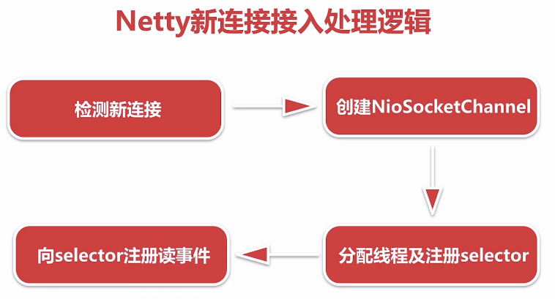

##### 5.2.1 检测新连接

新连接通过服务端channel绑定的selector轮询出accpet事件（即I/O事件）

##### 5.2.2 创建NioSocketChannel

基于JDK nio的channel创建一个netty的nioSocketChannel，也就是客户端channel

##### 5.2.3 分配线程及注册selector

netty给客户端channel分配NioEventLoop并把这条channel注册到NioEventLoop对应的selector上，至此这条channel后续相关的读写都由此NioEventLoop管理

##### 5.2.4 向selector注册读事件

注册的过程和服务端启动注册的accept事件复用同一段逻辑

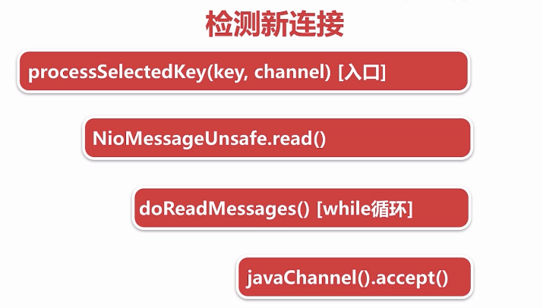

断点调试：启动服务端 ---》telnet 127.0.0.1 8888方式创建新的连接

小结：

在服务端channel的NioEventLoop run（）的 第二个过程：

--》NioEventLoop#processSelectedKey(SelectionKey, AbstractNioChannel) 检测出accept事件之后，

--》通过jdk的accept方法创建jdk的channel，

--》并包装成netty自定义的channel，

--》List readBuf 临时存放channnel，

--》此过程中通过Handle对象控制连接接入的速率，默认情况下一次性读取16个连接

io.netty.channel.nio.AbstractNioMessageChannel.NioMessageUnsafe#read

public void read() {  
 assert eventLoop().inEventLoop();  
 final ChannelConfig config = config();  
 final ChannelPipeline pipeline = pipeline();  
 final RecvByteBufAllocator.Handle allocHandle = unsafe().recvBufAllocHandle();  
 allocHandle.reset(config);  
 boolean closed = false;  
 Throwable exception = null;  
 try {  
 try {  
 do {  
 int localRead = doReadMessages(readBuf);  
 if (localRead == 0) {  
 break;  
 }  
 if (localRead < 0) {  
 closed = true;  
 break;  
 }  
  
 allocHandle.incMessagesRead(localRead);  
 } while (allocHandle.continueReading());  
 } catch (Throwable t) {  
 exception = t;  
 }  
  
 int size = readBuf.size();  
 for (int i = 0; i < size; i ++) {  
 readPending = false;  
 pipeline.fireChannelRead(readBuf.get(i));  
 }  
 readBuf.clear();  
 allocHandle.readComplete();  
 pipeline.fireChannelReadComplete();  
  
 if (exception != null) {  
 closed = closeOnReadError(exception);  
  
 pipeline.fireExceptionCaught(exception);  
 }  
  
 if (closed) {  
 inputShutdown = true;  
 if (isOpen()) {  
 close(voidPromise());  
 }  
 }  
 } finally {  
 // See https://github.com/netty/netty/issues/2254  
 if (!readPending && !config.isAutoRead()) {  
 removeReadOp();  
 }  
 }  
 }  
}

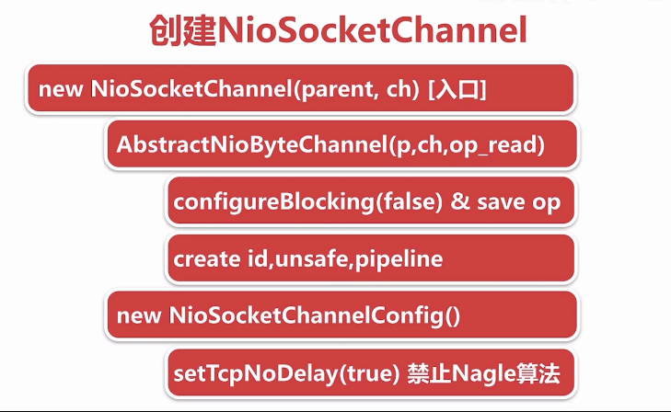

客户端channel创建完成之后，将服务端channel和客户端channel作为参数传递到NioSocketChannel的构造函数中，接下来进行一系列的创建过程。

// this 代表创建客户端channel的服务端nioServerSocketChannel（通过反射创建） ch 代表jdk accept创建的channel   
//new NioSocketChannel 构造出来的netty的客户端channel  
new NioSocketChannel(this, ch)；  
...  
public NioSocketChannel(Channel parent, SocketChannel socket) {  
 super(parent, socket);  
 config = new NioSocketChannelConfig(this, socket.socket());  
 }

NioSocketChannel的构造函数是入口。做两件事情：

* 逐层调用父类的构造函数
  + 配置此channel为非阻塞，将感兴趣的读事件OP_READ,保存到成员变量方便后续注册到selector上
  + protected AbstractNioChannel(Channel parent, SelectableChannel ch, int readInterestOp) {  
     super(parent);  
     this.ch = ch;  
     this.readInterestOp = readInterestOp;  
     try {  
     ch.configureBlocking(false);  
     } catch (IOException e) {  
     try {  
     ch.close();  
     } catch (IOException e2) {  
     if (logger.isWarnEnabled()) {  
     logger.warn(  
     "Failed to close a partially initialized socket.", e2);  
     }  
     }  
     throw new ChannelException("Failed to enter non-blocking mode.", e);  
     }  
    }
  + 创建和此channel相关的一些组件 id 作为channel的唯一标识 unsafe作为底层数据读写 pipeline作为业务逻辑的载体。
  + protected AbstractChannel(Channel parent) {  
     this.parent = parent;  
     id = newId();  
     unsafe = newUnsafe();  
     pipeline = newChannelPipeline();  
    }
* 创建一个和NioSocketChannel绑定的配置类
  + 设置此channel tcpNoDeply为 true，禁止negle算法（使小的数据包集合成大的数据包再发送出去），保证小的数据包尽可能发出去，降低延时
  + public DefaultSocketChannelConfig(SocketChannel channel, Socket javaSocket) {  
     super(channel);  
     if (javaSocket == null) {  
     throw new NullPointerException("javaSocket");  
     }  
     this.javaSocket = javaSocket;  
      
     // Enable TCP_NODELAY by default if possible.  
     if (PlatformDependent.canEnableTcpNoDelayByDefault()) {  
     try {  
     setTcpNoDelay(true);  
     } catch (Exception e) {  
     // Ignore.  
     }  
     }  
    }

思考：与创建服务端channel不同的是，服务端channel是利用反射创建，而这里直接使用new 关键词，netty为什么这么设计？

##### 5.3 Netty中channel的分类

* NioServerSocketChannel
  + Netty服务端channel的创建：用户代码传进来一个class类，netty拿到这个类通过反射方式创建。
* NioSocketChannel
  + 新连接接入过程中，拿到jdk底层创建的channel之后，通过显式的new关键字创建客户端channel
* unsafe
  + 用于实现每一种channel底层具体的协议

###### 5.3.1 netty中channel的层级关系

* **io.netty.channel.Channel：**
* A nexus to a network socket or a component which is capable of I/O  
  * operations such as read, write, connect, and bind.
* **io.netty.channel.AbstractChannel**
* A skeletal {@link Channel} implementation.  
  ...  
   private final Channel parent;  
   private final ChannelId id;  
   private final Unsafe unsafe;  
   private final DefaultChannelPipeline pipeline;  
  ...  
   private volatile EventLoop eventLoop;

**io.netty.channel.nio.AbstractNioChannel**

使用select轮询的的方式进行读写事件的监听

抽象出来，只关心I/O事件

Abstract base class for {@link Channel} implementations which use a Selector based approach.  
 ...  
 private final SelectableChannel ch;  
 protected final int readInterestOp;  
 volatile SelectionKey selectionKey;  
   
 ...  
 protected AbstractNioChannel(Channel parent, SelectableChannel ch, int readInterestOp) {  
 super(parent);  
 this.ch = ch;  
 this.readInterestOp = readInterestOp;  
 try {  
 ch.configureBlocking(false);  
 } catch (IOException e) {  
 ...

**io.netty.channel.nio.AbstractNioByteChannel**

io.netty.channel.nio.AbstractNioByteChannel#AbstractNioByteChannel

protected AbstractNioByteChannel(Channel parent, SelectableChannel ch) {  
 super(parent, ch, SelectionKey.OP_READ);  
}

客户端channel ：创建的时候调用父类AbstractNioChannel 的构造函数，传递 read事件（I/O事件） 读取数据

{@link AbstractNioChannel} base class for {@link Channel}s that operate on bytes.  
...  
public final void read() {  
 final ChannelConfig config = config();  
 final ChannelPipeline pipeline = pipeline();  
 final ByteBufAllocator allocator = config.getAllocator();  
 final RecvByteBufAllocator.Handle allocHandle = recvBufAllocHandle();  
 allocHandle.reset(config);  
 ByteBuf byteBuf = null;  
 boolean close = false;  
 try {  
 do {  
 byteBuf = allocHandle.allocate(allocator);  
 //读取字节数据  
 allocHandle.lastBytesRead(doReadBytes(byteBuf));  
 ...  
 } while (allocHandle.continueReading());  
 ...  
}

**io.netty.channel.nio.AbstractNioMessageChannel**

服务端channel：创建的时候调用父类AbstractNioChannel 的构造函数，传递accept事件（I/O事件），监听连接

* {@link AbstractNioChannel} base class for {@link Channel}s that operate on messages.  
   
 public void read() {  
 assert eventLoop().inEventLoop();  
 final ChannelConfig config = config();  
 final ChannelPipeline pipeline = pipeline();  
 final RecvByteBufAllocator.Handle allocHandle = unsafe().recvBufAllocHandle();  
 allocHandle.reset(config);  
 boolean closed = false;  
 Throwable exception = null;  
 try {  
 try {  
 do {  
 ...  
 int localRead = doReadMessages(readBuf);  
 ...  
 allocHandle.incMessagesRead(localRead);  
 } while (allocHandle.continueReading());  
 } catch (Throwable t) {  
 exception = t;  
 }  
  
 }

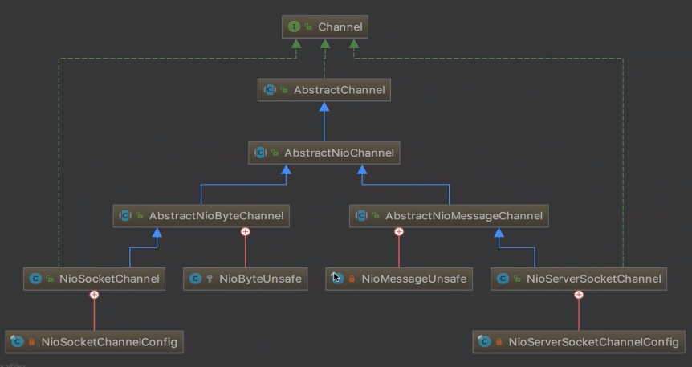

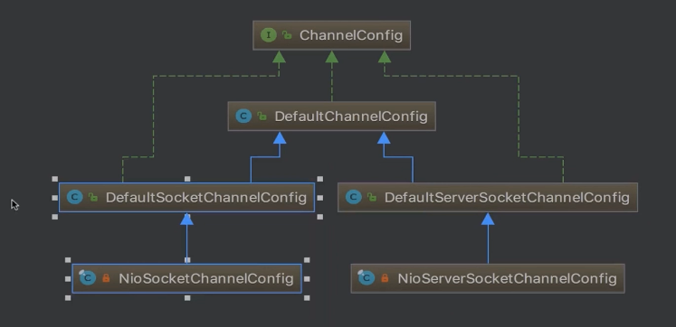

##### 5.4 新连接 NioEventLoop分配和Selector注册

io.netty.channel.nio.AbstractNioMessageChannel.NioMessageUnsafe#read

--》io.netty.channel.nio.AbstractNioMessageChannel#doReadMessages 创建客户端channel

@Override  
protected int doReadMessages(List<Object> buf) throws Exception {  
 SocketChannel ch = javaChannel().accept();  
 try {  
 if (ch != null) {  
 buf.add(new NioSocketChannel(this, ch));  
 return 1;  
 }  
 } catch (Throwable t) {  
 ...   
 }  
 return 0;  
}

* --》io.netty.channel.ChannelPipeline#fireChannelRead for循环遍历每一条客户端连接，调用服务端channel的PipeLine的fireChannelRead 方法

...  
for (int i = 0; i < size; i ++) {  
 readPending = false;  
 pipeline.fireChannelRead(readBuf.get(i));  
}  
...

* --》回顾netty服务端启动：io.netty.bootstrap.ServerBootstrap#init
* --》 服务端channel PipeLine的构成

服务端channel PipeLine传播channelRead事件会从head开始--ServerBootstrapAcceptor--最后到Tail

即 pipeline.fireChannelRead(readBuf.get(i)) 会将每一条客户端连接通过fireChannelRead逐层传到ServerBootstrapAcceptor，即调用io.netty.bootstrap.ServerBootstrap.ServerBootstrapAcceptor#channelRead

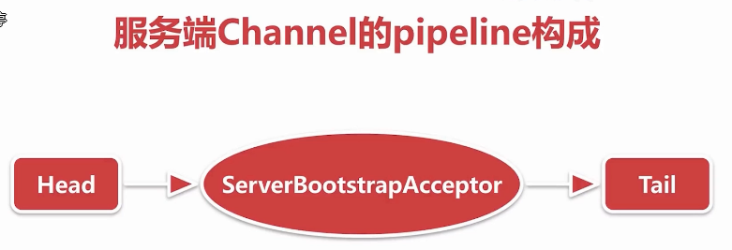

* --》ServerBootstrapAcceptor#channelRead主要做以下几件事情
  + 添加childHandler
  + 设置options和attrs
  + 选择NioEventLoop并注册selector

public void channelRead(ChannelHandlerContext ctx, Object msg) {  
 final Channel child = (Channel) msg;  
 //这里的childHandler是以一个特殊的handler，即服务端启动时传进来的ChannelInitializer  
 child.pipeline().addLast(childHandler);  
 //childOptions 底层jdk读写相关的参数  
 for (Entry<ChannelOption<?>, Object> e: childOptions) {  
 try {  
 if (!child.config().setOption((ChannelOption<Object>) e.getKey(), e.getValue())) {  
 logger.warn("Unknown channel option: " + e);  
 }  
 } catch (Throwable t) {  
 logger.warn("Failed to set a channel option: " + child, t);  
 }  
 }  
 //childAttrs 在客户端channel上绑定一些自定义的属性 如密钥 channel存活时间等  
 for (Entry<AttributeKey<?>, Object> e: childAttrs) {  
 child.attr((AttributeKey<Object>) e.getKey()).set(e.getValue());  
 }  
  
 try {  
 // childGroup 是一个workGroup 注册的时候选择一个NioEventLoop进行注册  
 childGroup.register(child).addListener(new ChannelFutureListener() {  
 @Override  
 public void operationComplete(ChannelFuture future) throws Exception {  
 if (!future.isSuccess()) {  
 forceClose(child, future.cause());  
 }  
 }  
 });  
 } catch (Throwable t) {  
 forceClose(child, t);  
 }  
}

io.netty.channel.ChannelInitializer#handlerAdded --》

io.netty.channel.ChannelInitializer#initChannel(io.netty.channel.ChannelHandlerContext)

private boolean initChannel(ChannelHandlerContext ctx) throws Exception {  
 if (initMap.putIfAbsent(ctx, Boolean.TRUE) == null) { // Guard against re-entrance.  
 try {  
 //这里会回调到用户代码里的方法ChannelInitializer#initChannel(io.netty.channel.socket.SocketChannel)  
 initChannel((C) ctx.channel());  
 } catch (Throwable cause) {  
 // Explicitly call exceptionCaught(...) as we removed the handler before calling initChannel(...).  
 // We do so to prevent multiple calls to initChannel(...).  
 exceptionCaught(ctx, cause);  
 } finally {  
 //调用remove将自身删除  
 remove(ctx);  
 }  
 return true;  
 }  
 return false;  
}  
//这就是netty为新连接添加channelHandler的逻辑

io.netty.channel.EventLoopGroup#register(io.netty.channel.Channel)

io.netty.channel.MultithreadEventLoopGroup#register(io.netty.channel.Channel)  
@Override  
public ChannelFuture register(Channel channel) {  
 return next().register(channel);  
}

next()返回一个NioEventLoop

@Override  
public EventLoop next() {  
 return (EventLoop) super.next();  
}

io.netty.util.concurrent.MultithreadEventExecutorGroup#next

@Override  
public EventExecutor next() {  
 return chooser.next();  
}

客户端channel选择nioEventLoop并注册selector的过程

io.netty.channel.SingleThreadEventLoop#register(io.netty.channel.ChannelPromise)  
@Override  
public ChannelFuture register(final ChannelPromise promise) {  
 ObjectUtil.checkNotNull(promise, "promise");  
 promise.channel().unsafe().register(this, promise);  
 return promise;  
}

io.netty.channel.nio.AbstractNioChannel#doRegister  
protected void doRegister() throws Exception {  
 boolean selected = false;  
 for (;;) {  
 try {  
 selectionKey = javaChannel().register(eventLoop().selector, 0, this);  
 return;  
 } catch (CancelledKeyException e) {  
 if (!selected) {  
 eventLoop().selectNow();  
 selected = true;  
 } else {  
 throw e;  
 }  
 }  
 }  
}

小结：服务端channel在检测到新连接并且创建完客户端channel之后，会调用一个连接器做一些处理，

包括给客户端channel填充逻辑处理器channelHanler，配置options和attrs，选定一个NioEventLoop进行绑定，并把channel注册到NioEventLoop的selector上，这时不关心任何事件。

##### 5.5 NioSocketChannel读事件的注册

io.netty.channel.AbstractChannel.AbstractUnsafe#register0

通过debug方式了解相应代码

io.netty.channel.DefaultChannelPipeline.HeadContext#channelActive

@Override  
public void channelActive(ChannelHandlerContext ctx) throws Exception {  
 //传播channelActive 事件  
 ctx.fireChannelActive();  
  
 readIfIsAutoRead();  
}

private void readIfIsAutoRead() {  
 if (channel.config().isAutoRead()) {//默认只要绑定端口就会接收连接，只要当前连接绑定到selector上就会自动读，即向selector上注册读事件  
 channel.read();  
 }  
}

io.netty.channel.AbstractChannel#read

public Channel read() {  
 pipeline.read();  
 return this;  
}

io.netty.channel.DefaultChannelPipeline#read

public final ChannelPipeline read() {  
 tail.read();  
 return this;  
}

io.netty.channel.AbstractChannelHandlerContext#invokeRead

private void invokeRead() {  
 if (invokeHandler()) {  
 try {  
 ((ChannelOutboundHandler) handler()).read(this);  
 } catch (Throwable t) {  
 notifyHandlerException(t);  
 }  
 } else {  
 read();  
 }  
}

io.netty.channel.DefaultChannelPipeline.HeadContext#read

public void read(ChannelHandlerContext ctx) {  
 unsafe.beginRead();  
}

io.netty.channel.AbstractChannel.AbstractUnsafe#beginRead

public final void beginRead() {  
 assertEventLoop();  
 ...  
 try {  
 doBeginRead();  
 } catch (final Exception e) {  
 ...  
 }  
}

io.netty.channel.nio.AbstractNioChannel#doBeginRead

protected void doBeginRead() throws Exception {  
 // Channel.read() or ChannelHandlerContext.read() was called  
 final SelectionKey selectionKey = this.selectionKey;  
 if (!selectionKey.isValid()) {  
 return;  
 }  
  
 readPending = true;  
   
 final int interestOps = selectionKey.interestOps();  
 //readInterestOp 即创建nioSocketChannel时传进来的OP_READ  
 if ((interestOps & readInterestOp) == 0) {  
 selectionKey.interestOps(interestOps | readInterestOp);  
 }  
}

#### 六. netty-PipeLine

PipeLine是netty的大动脉，主要负责读写事件的传播

##### 6.1 思考问题

* netty是如何判断ChannelHandler类型的
  + 调用pipeline添加handlerContext节点的时候，根据instanceOf关键词，判断当前节点是inbound还是outbound类型，并用一个boolean类型的变量标识
* 对于ChannelHandler的添加应遵循什么样的顺序
  + inbound类型事件的传播与添加inboundHanler的顺序正相关
  + outbound类型事件的传播与添加outboundHanler的顺序正相关
* 用户手动触发事件传播，不同的触发方式有什么样的区别？
  + 通过channel触发时，从tail或head节点往下传播
  + 通过当前节点触发时，从当前节点开始往下传播

##### 6.2 学习内容

* pipeLine的初始化
* 添加和删除ChannelHandler
* 事件和异常的传播

##### 6.3 pipeLine的初始化

###### 6.3.1 pipeline在创建channel的时候被创建

不管服务端channel还是客户端channel，都会调用abstractChannel的构造函数

io.netty.channel.AbstractChannel#AbstractChannel(io.netty.channel.Channel, io.netty.channel.ChannelId)

protected AbstractChannel(Channel parent, ChannelId id) {  
 this.parent = parent;  
 this.id = id;  
 unsafe = newUnsafe();  
 pipeline = newChannelPipeline();  
}

io.netty.channel.DefaultChannelPipeline#DefaultChannelPipeline

protected DefaultChannelPipeline(Channel channel) {  
 this.channel = ObjectUtil.checkNotNull(channel, "channel");  
 succeededFuture = new SucceededChannelFuture(channel, null);  
 voidPromise = new VoidChannelPromise(channel, true);  
  
 tail = new TailContext(this);  
 head = new HeadContext(this);  
  
 //通过next和prev将tail和head变成一个双向链表数据结构  
 head.next = tail;  
 tail.prev = head;  
}

###### 6.3.2 pipeline节点数据结构：ChannelHandlerContext

pipeline的每一个节点都是ChannelHandlerContext这种数据结构

public interface ChannelHandlerContext extends AttributeMap, ChannelInboundInvoker, ChannelOutboundInvoker {  
 /**   
 * Return the {@link Channel} which is bound to the {@link ChannelHandlerContext}.  
 */  
 Channel channel();  
  
 /**对应nioEventLoop  
 * Returns the {@link EventExecutor} which is used to execute an arbitrary task.  
 */  
 EventExecutor executor();  
  
 /**  
 * The unique name of the {@link ChannelHandlerContext}.The name was used when then {@link ChannelHandler}  
 * was added to the {@link ChannelPipeline}. This name can also be used to access the registered  
 * {@link ChannelHandler} from the {@link ChannelPipeline}.  
 */  
 String name();  
  
 /**  
 * The {@link ChannelHandler} that is bound this {@link ChannelHandlerContext}.  
 */  
 ChannelHandler handler();  
  
 /**  
 * Return {@code true} if the {@link ChannelHandler} which belongs to this context was removed  
 * from the {@link ChannelPipeline}. Note that this method is only meant to be called from with in the  
 * {@link EventLoop}.  
 */  
 boolean isRemoved();  
  
 @Override  
 ChannelHandlerContext fireChannelRegistered();  
  
 @Override  
 ChannelHandlerContext fireChannelUnregistered();  
  
 @Override  
 ChannelHandlerContext fireChannelActive();  
  
 @Override  
 ChannelHandlerContext fireChannelInactive();  
  
 @Override  
 ChannelHandlerContext fireExceptionCaught(Throwable cause);  
  
 @Override  
 ChannelHandlerContext fireUserEventTriggered(Object evt);  
  
 @Override  
 ChannelHandlerContext fireChannelRead(Object msg);  
  
 @Override  
 ChannelHandlerContext fireChannelReadComplete();  
  
 @Override  
 ChannelHandlerContext fireChannelWritabilityChanged();  
  
 @Override  
 ChannelHandlerContext read();  
  
 @Override  
 ChannelHandlerContext flush();  
  
 /**  
 * Return the assigned {@link ChannelPipeline}  
 */  
 ChannelPipeline pipeline();  
  
 /**内存分配器 ：当前节点有数据读写，分配bytebuf的时候用哪个内存分配器分配  
 * Return the assigned {@link ByteBufAllocator} which will be used to allocate {@link ByteBuf}s.  
 */  
 ByteBufAllocator alloc();  
  
 /**  
 * @deprecated Use {@link Channel#attr(AttributeKey)}  
 */  
 @Deprecated  
 @Override  
 <T> Attribute<T> attr(AttributeKey<T> key);  
  
 /**  
 * @deprecated Use {@link Channel#hasAttr(AttributeKey)}  
 */  
 @Deprecated  
 @Override  
 <T> boolean hasAttr(AttributeKey<T> key);  
}

* io.netty.util.AttributeMap 存储自定义属性
* io.netty.channel.ChannelInboundInvoker 传播读事件
* io.netty.channel.ChannelOutboundInvoker 传播写事件
* ChannelHandlerContext 的默认实现 io.netty.channel.AbstractChannelHandlerContext
  + //pipeline的串行结构主要依赖于以下两个属性  
    volatile AbstractChannelHandlerContext next;  
    volatile AbstractChannelHandlerContext prev;

###### 6.3.3 Pipeline两大哨兵 TailContext & HeadContext

Head节点 的unsafe负责实现channel的具体协议

Tail节点起到终止事件和异常传播的作用

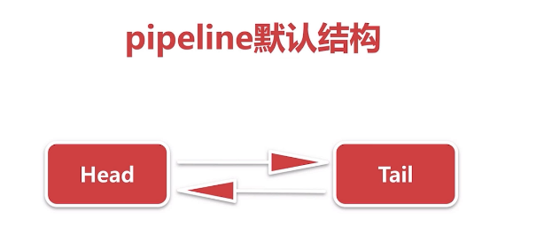

protected DefaultChannelPipeline(Channel channel) {  
 ...  
 tail = new TailContext(this);  
 head = new HeadContext(this);  
 ...  
}

* TailContext - inbound处理器

AbstractChannelHandlerContext(DefaultChannelPipeline pipeline, EventExecutor executor, String name,boolean inbound, boolean outbound) {  
 this.name = ObjectUtil.checkNotNull(name, "name");  
 this.pipeline = pipeline;  
 this.executor = executor;  
 this.inbound = inbound;  
 this.outbound = outbound;  
 // Its ordered if its driven by the EventLoop or the given Executor is an instanceof OrderedEventExecutor.  
 ordered = executor == null || executor instanceof OrderedEventExecutor;  
}

// A special catch-all handler that handles both bytes and messages.  
final class TailContext extends AbstractChannelHandlerContext implements ChannelInboundHandler {  
  
 TailContext(DefaultChannelPipeline pipeline) {  
 super(pipeline, null, TAIL_NAME, true, false);  
 setAddComplete();//设置已添加标记  
 }  
 //业务逻辑处理器  
 @Override  
 public ChannelHandler handler() {  
 return this;  
 }  
  
 @Override  
 public void channelRegistered(ChannelHandlerContext ctx) throws Exception { }//空  
  
 @Override  
 public void channelUnregistered(ChannelHandlerContext ctx) throws Exception { }//空  
  
 @Override  
 public void channelActive(ChannelHandlerContext ctx) throws Exception { }//空  
  
 @Override  
 public void channelInactive(ChannelHandlerContext ctx) throws Exception { }//空  
  
 @Override  
 public void channelWritabilityChanged(ChannelHandlerContext ctx) throws Exception { }  
  
 @Override  
 public void handlerAdded(ChannelHandlerContext ctx) throws Exception { }//空  
  
 @Override  
 public void handlerRemoved(ChannelHandlerContext ctx) throws Exception { }//空  
  
 @Override  
 public void userEventTriggered(ChannelHandlerContext ctx, Object evt) throws Exception {  
 // This may not be a configuration error and so don't log anything.  
 // The event may be superfluous for the current pipeline configuration.  
 ReferenceCountUtil.release(evt);  
 }  
 //发生异常时进行处理  
 @Override  
 public void exceptionCaught(ChannelHandlerContext ctx, Throwable cause) throws Exception {  
 onUnhandledInboundException(cause);  
 }  
 //传进来的消息未被处理时会触发  
 @Override  
 public void channelRead(ChannelHandlerContext ctx, Object msg) throws Exception {  
 onUnhandledInboundMessage(msg);  
 }  
  
 @Override  
 public void channelReadComplete(ChannelHandlerContext ctx) throws Exception { }  
}

结论：TailHead主要做一些收尾的事情，如异常未处理好会给予警告，消息没处理会建议你处理

* HeadContext - outbound处理器
* final class HeadContext extends AbstractChannelHandlerContext  
   implements ChannelOutboundHandler, ChannelInboundHandler {  
   //处理底层数据读写  
   private final Unsafe unsafe;  
    
   HeadContext(DefaultChannelPipeline pipeline) {  
   super(pipeline, null, HEAD_NAME, false, true);  
   unsafe = pipeline.channel().unsafe();  
   setAddComplete();  
   }  
    
   @Override  
   public ChannelHandler handler() {  
   return this;  
   }  
    
   @Override  
   public void handlerAdded(ChannelHandlerContext ctx) throws Exception {  
   // NOOP  
   }  
    
   @Override  
   public void handlerRemoved(ChannelHandlerContext ctx) throws Exception {  
   // NOOP  
   }  
    
   @Override  
   public void bind(  
   ChannelHandlerContext ctx, SocketAddress localAddress, ChannelPromise promise)  
   throws Exception {  
   unsafe.bind(localAddress, promise);  
   }  
    
   @Override  
   public void connect(  
   ChannelHandlerContext ctx,  
   SocketAddress remoteAddress, SocketAddress localAddress,  
   ChannelPromise promise) throws Exception {  
   unsafe.connect(remoteAddress, localAddress, promise);  
   }  
    
   @Override  
   public void disconnect(ChannelHandlerContext ctx, ChannelPromise promise) throws Exception {  
   unsafe.disconnect(promise);  
   }  
    
   @Override  
   public void close(ChannelHandlerContext ctx, ChannelPromise promise) throws Exception {  
   unsafe.close(promise);  
   }  
    
   @Override  
   public void deregister(ChannelHandlerContext ctx, ChannelPromise promise) throws Exception {  
   unsafe.deregister(promise);  
   }  
    
   @Override  
   public void read(ChannelHandlerContext ctx) {  
   unsafe.beginRead();  
   }  
    
   @Override  
   public void write(ChannelHandlerContext ctx, Object msg, ChannelPromise promise) throws Exception {  
   unsafe.write(msg, promise);  
   }  
    
   @Override  
   public void flush(ChannelHandlerContext ctx) throws Exception {  
   unsafe.flush();  
   }  
    
   @Override  
   public void exceptionCaught(ChannelHandlerContext ctx, Throwable cause) throws Exception {  
   ctx.fireExceptionCaught(cause);  
   }  
    
   @Override  
   public void channelRegistered(ChannelHandlerContext ctx) throws Exception {  
   invokeHandlerAddedIfNeeded();  
   ctx.fireChannelRegistered();  
   }  
    
   @Override  
   public void channelUnregistered(ChannelHandlerContext ctx) throws Exception {  
   ctx.fireChannelUnregistered();  
    
   // Remove all handlers sequentially if channel is closed and unregistered.  
   if (!channel.isOpen()) {  
   destroy();  
   }  
   }  
    
   @Override  
   public void channelActive(ChannelHandlerContext ctx) throws Exception {  
   ctx.fireChannelActive();  
    
   readIfIsAutoRead();  
   }  
    
   @Override  
   public void channelInactive(ChannelHandlerContext ctx) throws Exception {  
   ctx.fireChannelInactive();  
   }  
    
   @Override  
   public void channelRead(ChannelHandlerContext ctx, Object msg) throws Exception {  
   ctx.fireChannelRead(msg);  
   }  
    
   @Override  
   public void channelReadComplete(ChannelHandlerContext ctx) throws Exception {  
   ctx.fireChannelReadComplete();  
    
   readIfIsAutoRead();  
   }  
    
   private void readIfIsAutoRead() {  
   if (channel.config().isAutoRead()) {  
   channel.read();  
   }  
   }  
    
   @Override  
   public void userEventTriggered(ChannelHandlerContext ctx, Object evt) throws Exception {  
   ctx.fireUserEventTriggered(evt);  
   }  
    
   @Override  
   public void channelWritabilityChanged(ChannelHandlerContext ctx) throws Exception {  
   ctx.fireChannelWritabilityChanged();  
   }  
  }

结论：HeadContext 主要做的事情：1) 往下传播读写事件：netty每次传播读写事件都会从Head开始

2）读写事件委托给 unsafe 进行读写

##### 6.4 Pipeline 添加ChannelHandler

* 判断是否重复添加ChannelHandler
* 创建节点并添加至链表
  + 创建的节点就是ChannelHandlerContext，将ChannelHandler包装成ChannelHandlerContext添加到链表
* 回调添加完成事件
  + ChannelInitializer被添加完成之后会回调到用户代码（自己实现的initChannel()方法）

//用户代码 ChannelInitializer 是个抽象方法  
bootstrap.group(bossGroup, workGroup)  
 .channel(NioServerSocketChannel.class)  
 .childOption(ChannelOption.TCP_NODELAY, true)  
 .childAttr(AttributeKey.newInstance("childAttr"), "childAttrValue")  
 .handler(new ServerHandler())  
 .childHandler(new ChannelInitializer<SocketChannel>() {  
  
 @Override  
 protected void initChannel(SocketChannel ch) throws Exception {  
 ch.pipeline().addLast(new ChannelInboundHandlerAdapter());  
 ch.pipeline().addLast(new ChannelOutboundHandlerAdapter());  
 }  
 });

io.netty.channel.DefaultChannelPipeline#addLast(io.netty.util.concurrent.EventExecutorGroup, java.lang.String, io.netty.channel.ChannelHandler)

@Override  
public final ChannelPipeline addLast(EventExecutorGroup group, String name, ChannelHandler handler) {  
 final AbstractChannelHandlerContext newCtx;  
 synchronized (this) {  
 // 判断是否重复添加  
 checkMultiplicity(handler);  
 // 创建节点  
 newCtx = newContext(group, filterName(name, handler), handler);  
 //并添加至链表  
 addLast0(newCtx);  
  
 // If the registered is false it means that the channel was not registered on an eventloop yet.  
 // In this case we add the context to the pipeline and add a task that will call  
 // ChannelHandler.handlerAdded(...) once the channel is registered.  
 if (!registered) {  
 newCtx.setAddPending();  
 callHandlerCallbackLater(newCtx, true);  
 return this;  
 }  
 EventExecutor executor = newCtx.executor();  
   
 if (!executor.inEventLoop()) {  
 newCtx.setAddPending();  
 //io.netty.util.concurrent.SingleThreadEventExecutor#execute 添加到Mpsc队列  
 executor.execute(new Runnable() {  
 @Override  
 public void run() {  
 callHandlerAdded0(newCtx);  
 }  
 });  
 return this;  
 }  
 }  
 //  
 callHandlerAdded0(newCtx);  
 return this;  
}

io.netty.channel.DefaultChannelPipeline#callHandlerAdded0

private void callHandlerAdded0(final AbstractChannelHandlerContext ctx) {  
 try {  
 //回调到用户代码:io.netty.channel.ChannelInitializer#handlerAdded  
 ctx.handler().handlerAdded(ctx);  
 //自旋 + CAS 设置已添加标记 ADD_COMPLETE  
 ctx.setAddComplete();  
 } catch (Throwable t) {  
 boolean removed = false;  
 try {  
 //删除当前节点  
 remove0(ctx);  
 try {  
 ctx.handler().handlerRemoved(ctx);  
 } finally {  
 ctx.setRemoved();  
 }  
 removed = true;  
 } catch (Throwable t2) {  
 if (logger.isWarnEnabled()) {  
 logger.warn("Failed to remove a handler: " + ctx.name(), t2);  
 }  
 }  
 ...  
}

io.netty.channel.ChannelInitializer#handlerAdded

public void handlerAdded(ChannelHandlerContext ctx) throws Exception {  
 if (ctx.channel().isRegistered()) {  
 ...  
 initChannel(ctx);  
 }  
}

io.netty.channel.ChannelInitializer#initChannel(C)

//抽象方法  
protected abstract void initChannel(C ch) throws Exception;

##### 6.5 删除ChannelHandler

###### 6.5.1 应用场景 之 权限校验

public class AuthHandler extends SimpleChannelInboundHandler<ByteBuf> {  
  
 @Override  
 protected void channelRead0(ChannelHandlerContext ctx, ByteBuf msg) throws Exception {  
 if (pass(msg)) {  
 //校验通过将当前节点删除  
 ctx.pipeline().remove(this);  
 } else {  
 //校验不通过直接关闭连接  
 ctx.close();  
 }  
 }  
  
 private boolean pass(ByteBuf password) {  
 return false;  
 }  
}

###### 6.5.2 删除过程

* 找到节点
* io.netty.channel.DefaultChannelPipeline#getContextOrDie(io.netty.channel.ChannelHandler)
* io.netty.channel.DefaultChannelPipeline#context(io.netty.channel.ChannelHandler)
* //通过遍历链表的方式找到ChannelHandler对应的ChannelHandlerContext  
  public final ChannelHandlerContext context(ChannelHandler handler) {  
   if (handler == null) {  
   throw new NullPointerException("handler");  
   }  
   AbstractChannelHandlerContext ctx = head.next;  
   for (;;) {  
   if (ctx == null) {  
   return null;  
   }  
   if (ctx.handler() == handler) {  
   return ctx;  
   }  
   ctx = ctx.next;  
   }  
  }
* 链表的删除
* io.netty.channel.DefaultChannelPipeline#remove(io.netty.channel.AbstractChannelHandlerContext)
* //标准的链表删除节点方法  
  private static void remove0(AbstractChannelHandlerContext ctx) {  
   AbstractChannelHandlerContext prev = ctx.prev;  
   AbstractChannelHandlerContext next = ctx.next;  
   prev.next = next;  
   next.prev = prev;  
  }
* 回调删除Handler事件
* io.netty.channel.DefaultChannelPipeline#callHandlerRemoved0
* private void callHandlerRemoved0(final AbstractChannelHandlerContext ctx) {  
   // Notify the complete removal.  
   try {  
   try {  
   //这里会拿到当前节点的channelHandler，调用handlerRemoved方法，最终调用到回调方法里面  
   ctx.handler().handlerRemoved(ctx);  
   } finally {  
   //用户的回调方法执行结束之后，执行setRemoved方法  
   ctx.setRemoved();  
   }  
   } catch (Throwable t) {  
   fireExceptionCaught(new ChannelPipelineException(  
   ctx.handler().getClass().getName() + ".handlerRemoved() has thrown an exception.", t));  
   }  
  }

##### 6.6 inBound事件的传播

* 何为inBound事件以及ChannelInBoundHandler
* ChannelRead事件的传播
  + ChannelRead事件是典型的inbound事件
  + 按照添加handler的顺序传播
* SimpleInBoundHandler处理器
  + 自动释放bytebuf对象
* **netty中channelHandler接口的继承关系如图**
* 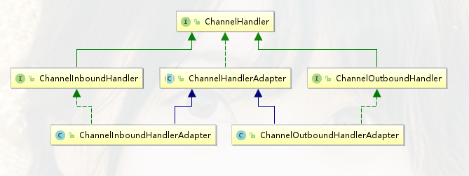
* 最顶层接口 ChannelHandler
* 默认实现 ChannelHandlerAdapter
* ChannelInboundHandler和ChannelOutboundHandler：
* 继承了ChannelHandler接口，分别定制了一些特殊的功能
* 平时用户代码编写channelHandler较多用到：
* 直接继承：ChannelInboundHandlerAdapter 和ChannelOutboundHandlerAdapter

ChannelInboundHandler在ChannelHandler基础上做了扩展：

public interface ChannelInboundHandler extends ChannelHandler {  
  
 /**channel注册到nioEventLoop对应的selector后会回调到 ChannelHandler  
 */  
 void channelRegistered(ChannelHandlerContext ctx) throws Exception;  
  
 void channelUnregistered(ChannelHandlerContext ctx) throws Exception;  
  
 /**channel激活后的回调  
 */  
 void channelActive(ChannelHandlerContext ctx) throws Exception;  
  
 /**channel失效的回调  
 */  
 void channelInactive(ChannelHandlerContext ctx) throws Exception;  
  
 /**  
 channel读到了一些数据或是接收了一些连接，  
 对服务端channel而言，msg是连接   
 对客户端channel而言，msg是bytebuf数据  
 */  
 void channelRead(ChannelHandlerContext ctx, Object msg) throws Exception;  
  
 /**  
 读完之后的回调  
 */  
 void channelReadComplete(ChannelHandlerContext ctx) throws Exception;  
  
 void userEventTriggered(ChannelHandlerContext ctx, Object evt) throws Exception;  
  
 void channelWritabilityChanged(ChannelHandlerContext ctx) throws Exception;  
  
 /**  
 异常捕获的回调  
 */  
 @Override  
 @SuppressWarnings("deprecation")  
 void exceptionCaught(ChannelHandlerContext ctx, Throwable cause) throws Exception;  
}

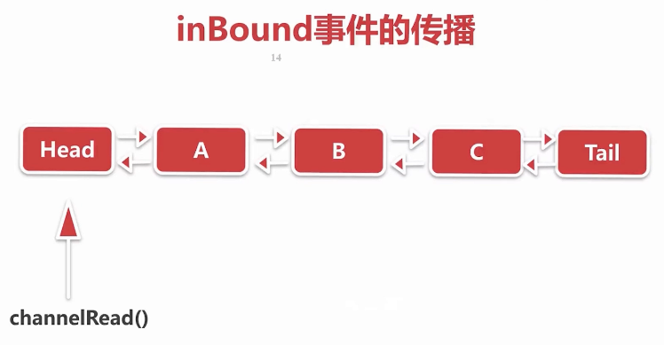

com.leh.netty.pipeline.InboundHandlerB

public class InboundHandlerB extends ChannelInboundHandlerAdapter {  
 /**  
 * channelHandler收到激活事件后会对收到对象进行打印，并继续传播  
 * @param ctx  
 * @param msg  
 * @throws Exception  
 */  
 @Override  
 public void channelRead(ChannelHandlerContext ctx, Object msg) throws Exception {  
 System.out.println("InboundHandlerB: " + msg);  
 //通过context调用fireChannelRead 会将事件从当前节点开始传播  
 ctx.fireChannelRead(msg);  
 }  
  
 /**  
 * 通道被激活的时候拿到对应的 pipeline ，激活一个ChannelRead事件  
 * @param ctx  
 * @throws Exception  
 */  
 @Override  
 public void channelActive(ChannelHandlerContext ctx) throws Exception {  
 //通过channel的Pipeline调用fireChannelRead  
 //会将事件从pipeline的headContext节点传播  
 ctx.channel().pipeline().fireChannelRead("hello netty");  
 }  
}

io.netty.channel.DefaultChannelPipeline#fireChannelRead

//从head开始  
public final ChannelPipeline fireChannelRead(Object msg) {  
 AbstractChannelHandlerContext.invokeChannelRead(head, msg);  
 return this;  
}

static void invokeChannelRead(final AbstractChannelHandlerContext next, Object msg) {  
 final Object m = next.pipeline.touch(ObjectUtil.checkNotNull(msg, "msg"), next);  
 //此时的next即io.netty.channel.DefaultChannelPipeline.HeadContext  
 EventExecutor executor = next.executor();  
 if (executor.inEventLoop()) {  
 //调用HeadContext的invokeChannelRead方法  
 next.invokeChannelRead(m);  
 } else {  
 executor.execute(new Runnable() {  
 @Override  
 public void run() {  
 next.invokeChannelRead(m);  
 }  
 });  
 }  
}

private void invokeChannelRead(Object msg) {  
 if (invokeHandler()) {  
 try {  
 ((ChannelInboundHandler) handler()).channelRead(this, msg);  
 } catch (Throwable t) {  
 notifyHandlerException(t);  
 }  
 } else {  
 fireChannelRead(msg);  
 }  
}

io.netty.channel.DefaultChannelPipeline.HeadContext#channelRead

@Override  
public void channelRead(ChannelHandlerContext ctx, Object msg) throws Exception {  
 ctx.fireChannelRead(msg);  
}

io.netty.channel.AbstractChannelHandlerContext#fireChannelRead

public ChannelHandlerContext fireChannelRead(final Object msg) {  
 //寻找下一个inboundHandler 找到之后通过invokeChannelRead 继续向下传播  
 invokeChannelRead(findContextInbound(), msg);  
 return this;  
}

io.netty.channel.AbstractChannelHandlerContext#findContextInbound

private AbstractChannelHandlerContext findContextInbound() {  
 AbstractChannelHandlerContext ctx = this;  
 do {  
 ctx = ctx.next;  
 } while (!ctx.inbound);  
 //inbound属性在addLast添加handler时候赋值的  
 //循环查找，找到inboundhandler即返回  
 return ctx;  
}

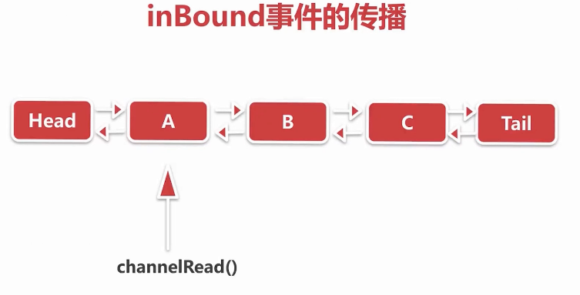

此时找到了下一个inboundHandler是com.leh.netty.pipeline.InboundHandlerA

io.netty.channel.AbstractChannelHandlerContext#invokeChannelRead(io.netty.channel.AbstractChannelHandlerContext, java.lang.Object)

static void invokeChannelRead(final AbstractChannelHandlerContext next, Object msg) {  
 final Object m = next.pipeline.touch(ObjectUtil.checkNotNull(msg, "msg"), next);  
 EventExecutor executor = next.executor();  
 //此时next是InboundHandlerA   
 if (executor.inEventLoop()) {  
 next.invokeChannelRead(m);  
 } else {  
 executor.execute(new Runnable() {  
 @Override  
 public void run() {  
 next.invokeChannelRead(m);  
 }  
 });  
 }  
}

com.leh.netty.pipeline.InboundHandlerA#channelRead

@Override  
public void channelRead(ChannelHandlerContext ctx, Object msg) throws Exception {  
 System.out.println("InboundHandlerA: " + msg);  
 //通过handler直接调用fireChannelRead 会把这个事件从当前节点开始往下传播  
 ctx.fireChannelRead(msg);  
}

同理,接下来继续传播到 B--》C-->Tail

到达TailContext节点，仍然是一个inboundHander

io.netty.channel.DefaultChannelPipeline.TailContext#channelRead

public void channelRead(ChannelHandlerContext ctx, Object msg) throws Exception {  
 onUnhandledInboundMessage(msg);  
}

io.netty.channel.DefaultChannelPipeline#onUnhandledInboundMessage

//消息传递直到tail节点都未被处理时进入该方法进行打印并释放  
protected void onUnhandledInboundMessage(Object msg) {  
 try {  
 logger.debug(  
 "Discarded inbound message {} that reached at the tail of the pipeline. " +  
 "Please check your pipeline configuration.", msg);  
 } finally {  
 ReferenceCountUtil.release(msg);  
 }  
}

**SimpleChannelInBoundHandler处理器**应用场景

当channelRead事件传播的时候，如果msg对象是个byteBuf，并且在handler中对byteBuf做了读写处理但没有继续向下传播，那么就传播不到tail节点，就没办法自动释放，这就需要用户自己释放，如果用户代码没有处理释放bytebuf，最终可能导致内存泄漏。

netty帮助我们封装了SimpleChannelInBoundHandler，能够自动释放byteBuf；

SimpleChannelInBoundHandler是如何做到自动释放byteBuf的？

public void channelRead(ChannelHandlerContext ctx, Object msg) throws Exception {  
 boolean release = true;  
 try {  
 if (acceptInboundMessage(msg)) {  
 @SuppressWarnings("unchecked")  
 I imsg = (I) msg;  
 channelRead0(ctx, imsg);  
 } else {  
 release = false;  
 ctx.fireChannelRead(msg);  
 }  
 } finally {  
 if (autoRelease && release) {  
 //最终由SimpleChannelInBoundHandler自动释放  
 ReferenceCountUtil.release(msg);  
 }  
 }  
}  
  
...  
 //channelRead0是个抽象方法  
 protected abstract void channelRead0(ChannelHandlerContext ctx, I msg) throws Exception;

public class AuthHandler extends SimpleChannelInboundHandler<ByteBuf> {  
  
 //用户只需要自己去覆盖SimpleChannelInboundHandler的channelRead0方法进行读写，不需要考虑释放bytebuf  
 @Override  
 protected void channelRead0方法(ChannelHandlerContext ctx, ByteBuf msg) throws Exception {  
 if (pass(msg)) {  
 //校验通过将当前节点删除  
 ctx.pipeline().remove(this);  
 } else {  
 //校验不通过直接关闭连接  
 ctx.close();  
 }  
 }  
 @Override  
 public void handlerRemoved(ChannelHandlerContext ctx) throws Exception {  
 System.out.println("test 回调删除");  
 }  
 private boolean pass(ByteBuf password) {  
 return true;  
 }  
}

##### 6.7 outBound事件的传播

###### 6.7.1 思考两个问题

* 何为outBound事件及channelOutBoundHandler
* write()事件的传播
* io.netty.channel.ChannelInboundHandler 被动触发的事件
* io.netty.channel.ChannelOutboundHandler 用户主动发起的事件
* public interface ChannelOutboundHandler extends ChannelHandler {  
   /**  
   * Called once a bind operation is made.  
   */  
   void bind(ChannelHandlerContext ctx, SocketAddress localAddress, ChannelPromise promise) throws Exception;  
    
   /**  
   * Called once a connect operation is made.  
   */  
   void connect(  
   ChannelHandlerContext ctx, SocketAddress remoteAddress,  
   SocketAddress localAddress, ChannelPromise promise) throws Exception;  
    
   void disconnect(ChannelHandlerContext ctx, ChannelPromise promise) throws Exception;  
    
   /**  
   * Called once a close operation is made.  
   */  
   void close(ChannelHandlerContext ctx, ChannelPromise promise) throws Exception;  
    
   void deregister(ChannelHandlerContext ctx, ChannelPromise promise) throws Exception;  
    
   /**  
   * Intercepts {@link ChannelHandlerContext#read()}.  
   */  
   void read(ChannelHandlerContext ctx) throws Exception;  
    
   /**  
   * Called once a write operation is made.   
   */  
   void write(ChannelHandlerContext ctx, Object msg, ChannelPromise promise) throws Exception;  
    
   /**  
   * Called once a flush operation is made.   
   */  
   void flush(ChannelHandlerContext ctx) throws Exception;  
  }

public final class TestChannelOutboundHandler {  
  
 public static void main(String[] args) {  
 // bossGroup 对应 socket编程中 server端 的 线程  
 EventLoopGroup bossGroup = new NioEventLoopGroup(1);  
 // workGroup 对应 socket编程中 client端 的 线程  
 EventLoopGroup workGroup = new NioEventLoopGroup();  
  
 ServerBootstrap bootstrap = new ServerBootstrap();  
  
 bootstrap.group(bossGroup, workGroup)  
 .channel(NioServerSocketChannel.class)  
 .childOption(ChannelOption.TCP_NODELAY, true)  
 .childAttr(AttributeKey.newInstance("childAttr"), "childAttrValue")  
 .childHandler(new ChannelInitializer<SocketChannel>() {  
  
 @Override  
 protected void initChannel(SocketChannel ch) throws Exception {  
 ch.pipeline().addLast(new OutboundHandlerA());  
 ch.pipeline().addLast(new OutboundHandlerB());  
 ch.pipeline().addLast(new OutboundHandlerC());  
 }  
 });  
 try {  
 //服务端创建的入口 bind()  
 ChannelFuture channelFuture = bootstrap.bind(8888).sync();  
 channelFuture.channel().closeFuture().sync();  
 } catch (InterruptedException e) {  
 e.printStackTrace();  
 }  
 }  
}  
  
output：结论：outboundHandler添加的顺序和在pipeline中传播的顺序是相反的  
OutboundHandlerC: hello netty  
OutboundHandlerB: hello netty  
OutboundHandlerA: hello netty

public class OutboundHandlerB extends ChannelOutboundHandlerAdapter {  
 @Override  
 public void write(ChannelHandlerContext ctx, Object msg, ChannelPromise promise) throws Exception {  
 System.out.println("OutboundHandlerB: " + msg);  
 //继续向下传播  
 ctx.write(msg, promise);  
 }  
  
 /**  
 * 做一个定时器的调用  
 * 模拟实际项目中读到数据处理完毕后给客户端一个响应  
 * @param ctx  
 * @throws Exception  
 */  
 @Override  
 public void handlerAdded(ChannelHandlerContext ctx) throws Exception {  
 ctx.executor().schedule(() -> {  
 //从Tail节点开始传播  
 ctx.channel().write("hello netty");  
 //从当前节点开始传播  
 //ctx.write("hello netty");  
 }, 3, TimeUnit.SECONDS);  
 }  
}

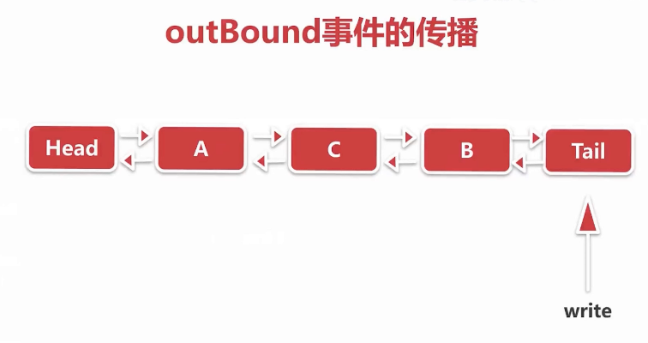

###### 6.7.2 源码分析

io.netty.channel.DefaultChannelPipeline#write(java.lang.Object) 委托给pipeline进行读写

//从Tail节点开始往前写  
public final ChannelFuture write(Object msg) {  
 return tail.write(msg);  
}

public ChannelFuture write(Object msg) {  
 //promise是一个回调  
 return write(msg, newPromise());  
}

private void write(Object msg, boolean flush, ChannelPromise promise) {  
 //寻找outbound节点  
 AbstractChannelHandlerContext next = findContextOutbound();  
 final Object m = pipeline.touch(msg, next);  
 EventExecutor executor = next.executor();  
 if (executor.inEventLoop()) {  
 if (flush) {  
 next.invokeWriteAndFlush(m, promise);  
 } else {  
 //找到B节点后调用  
 next.invokeWrite(m, promise);  
 }  
 } else {  
 AbstractWriteTask task;  
 if (flush) {  
 task = WriteAndFlushTask.newInstance(next, m, promise);  
 } else {  
 task = WriteTask.newInstance(next, m, promise);  
 }  
 safeExecute(executor, task, promise, m);  
 }  
}

io.netty.channel.AbstractChannelHandlerContext#findContextOutbound

private AbstractChannelHandlerContext findContextOutbound() {  
 AbstractChannelHandlerContext ctx = this;  
 do {  
 ctx = ctx.prev;  
 } while (!ctx.outbound);  
 return ctx;  
}

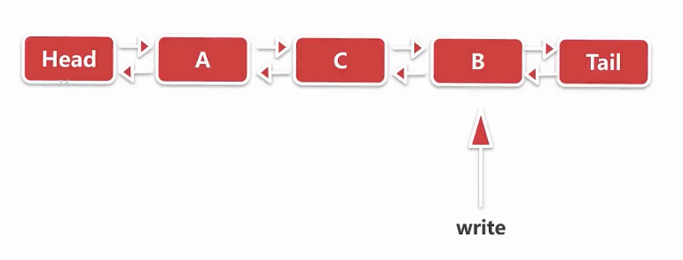

io.netty.channel.AbstractChannelHandlerContext#invokeWrite0

private void invokeWrite0(Object msg, ChannelPromise promise) {  
 try {  
 ((ChannelOutboundHandler) handler()).write(this, msg, promise);  
 } catch (Throwable t) {  
 notifyOutboundHandlerException(t, promise);  
 }  
}

com.leh.netty.pipeline.OutboundHandlerB#write

public void write(ChannelHandlerContext ctx, Object msg, ChannelPromise promise) throws Exception {  
 System.out.println("OutboundHandlerB: " + msg);  
 //继续向下传播  
 ctx.write(msg, promise);  
}

直到到达HeadContext节点

io.netty.channel.DefaultChannelPipeline.HeadContext#write

@Override  
public void write(ChannelHandlerContext ctx, Object msg, ChannelPromise promise) throws Exception {  
 //最终调用unsafe的write方法，不再往下传播  
 unsafe.write(msg, promise);  
}

##### 6.8 异常的传播

* inbound事件传播的顺序和在应用程序中添加inboundHandler的顺序正相关
* outbound事件传播的顺序和在应用程序中添加outboundHandler的顺序逆相关
* 那么异常呢？

模拟异常传播

telnet 127.0.0.1 8888 模拟客户端连接

send ayt 模拟发送消息

public final class TestExceptionSpread {  
  
 public static void main(String[] args) {  
 // bossGroup 对应 socket编程中 server端 的 线程  
 EventLoopGroup bossGroup = new NioEventLoopGroup(1);  
 // workGroup 对应 socket编程中 client端 的 线程  
 EventLoopGroup workGroup = new NioEventLoopGroup();  
  
 ServerBootstrap bootstrap = new ServerBootstrap();  
  
 bootstrap.group(bossGroup, workGroup)  
 .channel(NioServerSocketChannel.class)  
 .childOption(ChannelOption.TCP_NODELAY, true)  
 .childAttr(AttributeKey.newInstance("childAttr"), "childAttrValue")  
 .childHandler(new ChannelInitializer<SocketChannel>() {  
 @Override  
 protected void initChannel(SocketChannel ch) throws Exception {  
 ch.pipeline().addLast(new ExceptionInboundHandlerA());  
 ch.pipeline().addLast(new ExceptionInboundHandlerB());  
 ch.pipeline().addLast(new ExceptionInboundHandlerC());  
 ch.pipeline().addLast(new ExceptionOutboundHandlerA());  
 ch.pipeline().addLast(new ExceptionOutboundHandlerB());  
 ch.pipeline().addLast(new ExceptionOutboundHandlerC());  
 }  
 });  
 try {  
 //服务端创建的入口 bind()  
 ChannelFuture channelFuture = bootstrap.bind(8888).sync();  
 channelFuture.channel().closeFuture().sync();  
 } catch (InterruptedException e) {  
 e.printStackTrace();  
 }  
 }  
}  
output：  
ExceptionInboundHandlerB.exceptionCaught  
ExceptionInboundHandlerC.exceptionCaught  
ExceptionOutboundHandlerA.exceptionCaught  
ExceptionOutboundHandlerB.exceptionCaught  
ExceptionOutboundHandlerC.exceptionCaught

模拟异常

public class ExceptionInboundHandlerB extends ChannelInboundHandlerAdapter {  
  
 //抛出异常  
 @Override  
 public void channelRead(ChannelHandlerContext ctx, Object msg) throws Exception {  
 throw new BusinessException("exception from ExceptionInboundHandlerB");  
 }  
  
 //抛出异常回调  
 @Override  
 public void exceptionCaught(ChannelHandlerContext ctx, Throwable cause) throws Exception {  
 System.out.println("ExceptionInboundHandlerB.exceptionCaught");  
 //异常向下传播  
 ctx.fireExceptionCaught(cause);  
 }  
}

###### 6.8.1 netty 异常的触发链

* netty异常的传播与channelHandler的添加顺序正相关，当其中某个channelHandler读写数据发生异常，就会把异常从当前节点开始逐个向下传播，如果传播到最后一个节点没有异常处理器的话，最终到Tail节点，tail节点默认会给一个告警，并进行异常信息的打印。

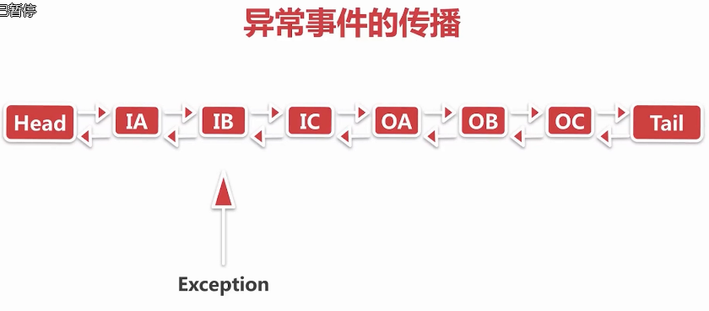

io.netty.channel.AbstractChannelHandlerContext#fireExceptionCaught

//向下传播直接拿到当前的节点的next节点  
public ChannelHandlerContext fireExceptionCaught(final Throwable cause) {  
 invokeExceptionCaught(next, cause);  
 return this;  
}

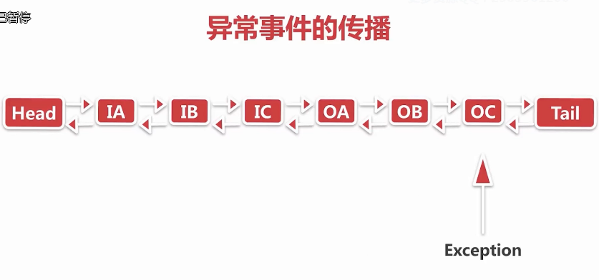

直到传播到Tail节点--》相当于哨兵

io.netty.channel.DefaultChannelPipeline.TailContext#exceptionCaught

public void exceptionCaught(ChannelHandlerContext ctx, Throwable cause) throws Exception {  
 onUnhandledInboundException(cause);  
}

io.netty.channel.DefaultChannelPipeline#onUnhandledInboundException  
protected void onUnhandledInboundException(Throwable cause) {  
 try {  
 logger.warn(  
 "An exceptionCaught() event was fired, and it reached at the tail of the pipeline. " +  
 "It usually means the last handler in the pipeline did not handle the exception.",  
 cause);  
 } finally {  
 ReferenceCountUtil.release(cause);  
 }  
}

###### 6.8.2 netty 实际项目中异常处理最佳实践

在每一条channelHandler链的最后添加终极的异常处理器，确保所有的异常若中途没有被处理，

都会落到此处理器，并且可以针对不同的异常类型分别处理

public class ExceptionCaughtHandler extends ChannelInboundHandlerAdapter {  
 @Override  
 public void exceptionCaught(ChannelHandlerContext ctx, Throwable cause) throws Exception {  
 //根据异常的类型进行处理  
 if (cause instanceof BusinessException) {  
 System.out.println("BusinessException");  
 }  
 }  
}

public final class TestExceptionSpread {  
  
 public static void main(String[] args) {  
   
 EventLoopGroup bossGroup = new NioEventLoopGroup(1);  
  
 EventLoopGroup workGroup = new NioEventLoopGroup();  
  
 ServerBootstrap bootstrap = new ServerBootstrap();  
  
 bootstrap.group(bossGroup, workGroup)  
 .channel(NioServerSocketChannel.class)  
 .childOption(ChannelOption.TCP_NODELAY, true)  
 .childAttr(AttributeKey.newInstance("childAttr"), "childAttrValue")  
 .childHandler(new ChannelInitializer<SocketChannel>() {  
  
 @Override  
 protected void initChannel(SocketChannel ch) throws Exception {  
 ch.pipeline().addLast(new ExceptionInboundHandlerA());  
 ch.pipeline().addLast(new ExceptionInboundHandlerB());  
 ch.pipeline().addLast(new ExceptionInboundHandlerC());  
 ch.pipeline().addLast(new ExceptionOutboundHandlerA());  
 ch.pipeline().addLast(new ExceptionOutboundHandlerB());  
 ch.pipeline().addLast(new ExceptionOutboundHandlerC());  
 //添加终极异常处理器  
 ch.pipeline().addLast(new ExceptionCaughtHandler());  
 }  
 });  
 try {  
 //服务端创建的入口 bind()  
 ChannelFuture channelFuture = bootstrap.bind(8888).sync();  
 channelFuture.channel().closeFuture().sync();  
 } catch (InterruptedException e) {  
 e.printStackTrace();  
 }  
 }  
}  
//output：  
ExceptionInboundHandlerB.exceptionCaught  
ExceptionInboundHandlerC.exceptionCaught  
ExceptionOutboundHandlerA.exceptionCaught  
ExceptionOutboundHandlerB.exceptionCaught  
ExceptionOutboundHandlerC.exceptionCaught  
BusinessException

#### 七、netty - byteBuf

本章是netty内存分配相关的内容, byteBuf 是直接与底层i/o打交道的一层抽象。

##### 7.1 思考问题

* 内存的类别有哪些
  + 堆内内存 和堆外内存
* 如何减少多线程内存分配之间的竞争
* 不同大小的内存是如何进行分配的

##### 7.2 本章主要内容

* 内存与内存管理器的抽象
* 不同规格大小和不同类别的内存的分配策略
* 内存的回收过程

##### 7.3 byteBuf的结构以及重要API

###### 7.3.1 byteBuf结构

* <pre>  
* +-------------------+------------------+------------------+  
* | discardable bytes | readable bytes | writable bytes |  
* | | (CONTENT) | |  
* +-------------------+------------------+------------------+  
* | | | |  
* 0 <= readerIndex <= writerIndex <= capacity (<= MaxCapacity)  
* </pre>

readerIndex :若读操作，从当前指针开始读数据

writerIndex：若写操作，从当前指针开始写

0 - readerIndex 无效的数据

readerIndex - writerIndex 可读的数据

writerIndex - capacity 表明这段空闲的，可以进行写

capacity - MaxCapacity 当写的空间不足，netty会提前将writable bytes部分会进行扩容，MaxCapacity 表示最大能扩充的空间，若仍超过此空间，则会拒绝

###### 7.3.2 read， write ， set方法

###### 7.3.3 mark 和reset方法

##### 7.4 byteBuf的分类

* pooled 和 unpooled
  + pooled 从池子中取一段预先分配好的内存
  + unpooled 直接调用现有的API去分配一块内存
* unsafe 和 非unsafe
  + unsafe 依赖jdk底层的unsafe对象
  + 非unsafe 不依赖jdk底层的unsafe对象
* Heap 和 Direct

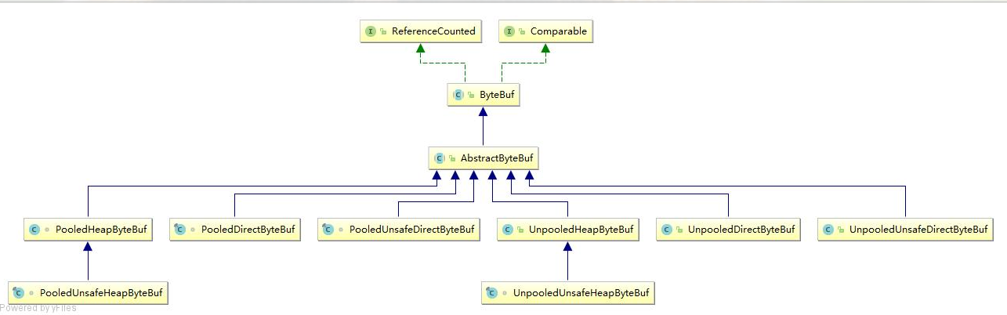

/**  
A skeletal implementation of a buffer. 实现基本骨架  
*/  
io.netty.buffer.AbstractByteBuf  
public abstract class AbstractByteBuf extends ByteBuf {  
 ...  
 int readerIndex;  
 int writerIndex;  
 private int markedReaderIndex;  
 private int markedWriterIndex;  
 private int maxCapacity;  
 ...  
}

##### 7.5 内存分配器 ByteBufAllocator分析

**思考：ByteBufAllocator是如何对上节中6中类型的byteBuf是如何分配的**

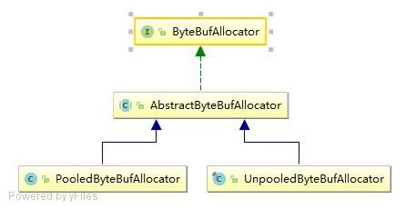

最顶层抽象 io.netty.buffer.ByteBufAllocator 负责分配所有类型的内存

* ByteBufAllocator
* AbstractByteBufAllocator
  + 暴露两个方法交给具体子类实现
  + /** 堆上内存  
     * Create a heap {@link ByteBuf} with the given initialCapacity and maxCapacity.  
     */  
    protected abstract ByteBuf newHeapBuffer(int initialCapacity, int maxCapacity);  
      
    /** 堆外内存  
     * Create a direct {@link ByteBuf} with the given initialCapacity and maxCapacity.  
     */  
    protected abstract ByteBuf newDirectBuffer(int initialCapacity, int maxCapacity);
* ByteBufAllocator 两大子类
  + PooledByteBufAllocator
  + UnpooledByteBufAllocator

##### 7.6 UnpooledByteBufAllocator 分析

* heap内存的分配
* io.netty.buffer.UnpooledByteBufAllocator#newHeapBuffer
* protected ByteBuf newHeapBuffer(int initialCapacity, int maxCapacity) {  
   // netty自己判断是否有unsafe对象  
   return PlatformDependent.hasUnsafe() ? new UnpooledUnsafeHeapByteBuf(this, initialCapacity, maxCapacity)  
   : new UnpooledHeapByteBuf(this, initialCapacity, maxCapacity);  
  }
* direct内存的分配
* protected ByteBuf newDirectBuffer(int initialCapacity, int maxCapacity) {  
   ByteBuf buf = PlatformDependent.hasUnsafe() ?  
   UnsafeByteBufUtil.newUnsafeDirectByteBuf(this, initialCapacity, maxCapacity) :  
   new UnpooledDirectByteBuf(this, initialCapacity, maxCapacity);  
    
   return disableLeakDetector ? buf : toLeakAwareBuffer(buf);  
  }

io.netty.buffer.UnpooledUnsafeDirectByteBuf#setByteBuffer  
final void setByteBuffer(ByteBuffer buffer, boolean tryFree) {  
 if (tryFree) {  
 ByteBuffer oldBuffer = this.buffer;  
 if (oldBuffer != null) {  
 if (doNotFree) {  
 doNotFree = false;  
 } else {  
 freeDirect(oldBuffer);  
 }  
 }  
 }  
 this.buffer = buffer;  
 //获取buffer内存地址并保存  
 memoryAddress = PlatformDependent.directBufferAddress(buffer);  
 tmpNioBuf = null;  
 capacity = buffer.remaining();  
}

io.netty.util.internal.PlatformDependent#directBufferAddress  
public static long directBufferAddress(ByteBuffer buffer) {  
 return PlatformDependent0.directBufferAddress(buffer);  
}

static long directBufferAddress(ByteBuffer buffer) {  
 return getLong(buffer, ADDRESS_FIELD_OFFSET);  
}

io.netty.util.internal.PlatformDependent0#getLong(java.lang.Object, long)

private static long getLong(Object object, long fieldOffset) {  
 return UNSAFE.getLong(object, fieldOffset);  
}

**取数据**

io.netty.buffer.UnpooledUnsafeDirectByteBuf#_getByte

protected byte _getByte(int index) {  
 return UnsafeByteBufUtil.getByte(addr(index));  
}

io.netty.buffer.UnsafeByteBufUtil#getByte(long)  
static byte getByte(long address) {  
 return PlatformDependent.getByte(address);  
}

io.netty.util.internal.PlatformDependent0#getByte(long)  
static byte getByte(long address) {  
 return UNSAFE.getByte(address);  
}

io.netty.buffer.UnpooledDirectByteBuf#_getByte

protected byte _getByte(int index) {  
 //调用jdk的ByteBuffer的API  
 return buffer.get(index);  
}

分析：unsafe和非unsafe的认识：

非unsafe 最终会通过一个内存地址 + 偏移量的方式去拿到对应的数据；

而非unsafe会通过 数组 + 下标 调用jdk底层的ByteBuffer的api去拿数据

一般而言通过unsafe取数据要快一点。

##### 7.7 PooledByteBufAllocator 分析

* 拿到线程局部缓存PoolThreadCache （多线程调用newHeapBuffer时拿到当前线程的cache）
* 在线程局部缓存的Area上进行内存分配

以io.netty.buffer.PooledByteBufAllocator#newHeapBuffer为例：

final class PoolThreadLocalCache extends FastThreadLocal<PoolThreadCache> {  
  
 @Override  
 protected synchronized PoolThreadCache initialValue() {  
 final PoolArena<byte[]> heapArena = leastUsedArena(heapArenas);  
 final PoolArena<ByteBuffer> directArena = leastUsedArena(directArenas);  
  
 return new PoolThreadCache(  
 heapArena, directArena, tinyCacheSize, smallCacheSize, normalCacheSize,  
 DEFAULT_MAX_CACHED_BUFFER_CAPACITY, DEFAULT_CACHE_TRIM_INTERVAL);  
 }  
 ......  
}

private final PoolThreadLocalCache threadCache;  
  
...  
protected ByteBuf newHeapBuffer(int initialCapacity, int maxCapacity) {  
 PoolThreadCache cache = threadCache.get();  
 PoolArena<byte[]> heapArena = cache.heapArena;  
  
 ByteBuf buf;  
 if (heapArena != null) {  
 buf = heapArena.allocate(cache, initialCapacity, maxCapacity);  
 } else {  
 buf = new UnpooledHeapByteBuf(this, initialCapacity, maxCapacity);  
 }  
  
 return toLeakAwareBuffer(buf);  
}

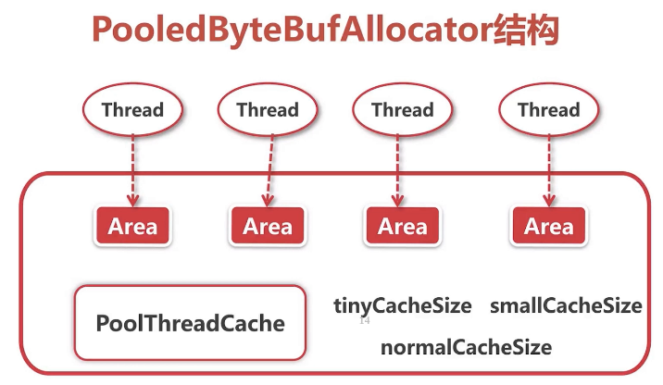

##### 7.8 directArena分配direct内存的流程

* 从对象池里面拿到PooledByteBuf进行复用
  + PoolThreadCache 是每一个线程都会维护的一个对象
* 从缓存上j进行内存分配
* 从内存堆里面进行内存分配

以io.netty.buffer.PooledByteBufAllocator#newDirectBuffer为例：

protected ByteBuf newDirectBuffer(int initialCapacity, int maxCapacity) {  
 PoolThreadCache cache = threadCache.get();  
 PoolArena<ByteBuffer> directArena = cache.directArena;  
  
 ByteBuf buf;  
 if (directArena != null) {  
 buf = directArena.allocate(cache, initialCapacity, maxCapacity);  
 } else {  
 if (PlatformDependent.hasUnsafe()) {  
 buf = UnsafeByteBufUtil.newUnsafeDirectByteBuf(this, initialCapacity, maxCapacity);  
 } else {  
 buf = new UnpooledDirectByteBuf(this, initialCapacity, maxCapacity);  
 }  
 }  
 return toLeakAwareBuffer(buf);  
}

io.netty.buffer.PoolArena#allocate(io.netty.buffer.PoolThreadCache, int, int)

PooledByteBuf<T> allocate(PoolThreadCache cache, int reqCapacity, int maxCapacity) {  
 //第一步 拿到byteBuf  
 PooledByteBuf<T> buf = newByteBuf(maxCapacity);  
 //第二步 进行内存分配 （先在缓存上进行内存分配，若未命中缓存，则进行实际的内存分配）  
 allocate(cache, buf, reqCapacity);  
 return buf;  
}

io.netty.buffer.PoolArena.DirectArena#newByteBuf

protected PooledByteBuf<ByteBuffer> newByteBuf(int maxCapacity) {  
 if (HAS_UNSAFE) {  
 return PooledUnsafeDirectByteBuf.newInstance(maxCapacity);  
 } else {  
 return PooledDirectByteBuf.newInstance(maxCapacity);  
 }  
}

io.netty.buffer.PooledUnsafeDirectByteBuf#newInstance

private static final Recycler<PooledUnsafeDirectByteBuf> RECYCLER = new Recycler<PooledUnsafeDirectByteBuf>() {  
 @Override  
 protected PooledUnsafeDirectByteBuf newObject(Handle<PooledUnsafeDirectByteBuf> handle) {  
 //handle负责byteBuf对象的回收  
 return new PooledUnsafeDirectByteBuf(handle, 0);  
 }  
 };  
  
static PooledUnsafeDirectByteBuf newInstance(int maxCapacity) {  
 //带有回收特性的对象池  
 PooledUnsafeDirectByteBuf buf = RECYCLER.get();  
 //复用byteBuf对象  
 buf.reuse(maxCapacity);  
 return buf;  
}

io.netty.buffer.PooledByteBuf#reuse

final void reuse(int maxCapacity) {  
 maxCapacity(maxCapacity);  
 setRefCnt(1);  
 setIndex0(0, 0);  
 discardMarks();  
}

##### 7.9 内存规格的介绍

不同大小内存的分配逻辑是不一样的。

为什么把16M作为分界点 ？

16M对应Chunk，所有的内存申请都是通过以Chunk为单位向操作系统进行申请的，后续所有的内存分配都是在Chunk里面做对应的操作。

例如 要分配一个1M的内存，首先申请一个16M的Chunk --》在16M里面取出一段内存作为1M --》把1M对应的连续内存扔到ByteBuf里面。

为什么把8K作为分界点 ？

16M可能有点大，把16M的Chunk按page的方式切分，16M/8k = 2^11个page=2048 1page = 8K

这样想要分配16k内存的时候，只需要找到两个连续的page即可，这样的分配更高效

比如要申请16个字节，如果以page进行分配，可能会很浪费，netty按照内存大小的规格把8K继续进行切分。

若要分配512B，将8k分成 8k/512个片段，每次找到一个空闲的片段进行分配即可。

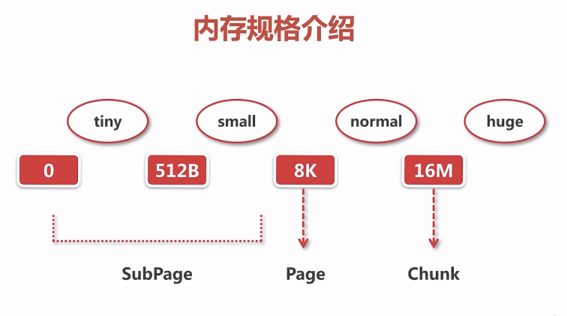

##### 7.10 缓存数据结构

netty中与缓存相关的数据结构: **MemoryRegionCache**

MemoryRegionCache由3部分组成：

* queue
  + 每一个元素是个实体entry
    - chunk 代表分配单位
    - handler 指向一段唯一连续的内存
* sizeClass netty中的内存规格
  + tiny
  + small
  + normal
* size

io.netty.buffer.PoolThreadCache

io.netty.buffer.PoolArena.SizeClass

enum SizeClass {  
 Tiny,  
 Small,  
 Normal  
 }

io.netty.buffer.PoolThreadCache.MemoryRegionCache.Entry

static final class Entry<T> {  
 final Handle<Entry<?>> recyclerHandle;  
 PoolChunk<T> chunk;  
 long handle = -1;  
  
 Entry(Handle<Entry<?>> recyclerHandle) {  
 this.recyclerHandle = recyclerHandle;  
 }  
  
 void recycle() {  
 chunk = null;  
 handle = -1;  
 recyclerHandle.recycle(this);  
 }  
}

io.netty.buffer.PoolThreadCache.MemoryRegionCache

private abstract static class MemoryRegionCache<T> {  
 private final int size;  
 private final Queue<Entry<T>> queue;  
 private final SizeClass sizeClass;  
 private int allocations;  
  
 MemoryRegionCache(int size, SizeClass sizeClass) {  
 this.size = MathUtil.safeFindNextPositivePowerOfTwo(size);  
 queue = PlatformDependent.newFixedMpscQueue(this.size);  
 this.sizeClass = sizeClass;  
 }  
 ......  
}

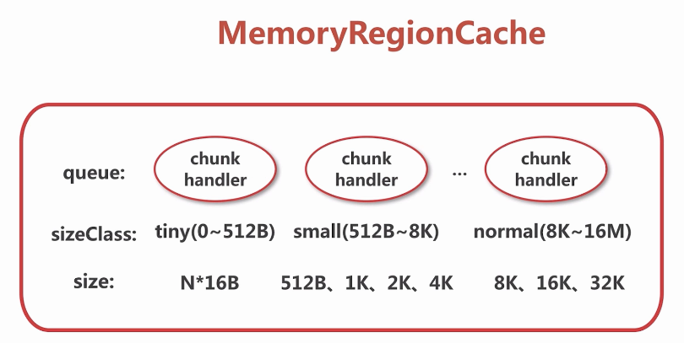

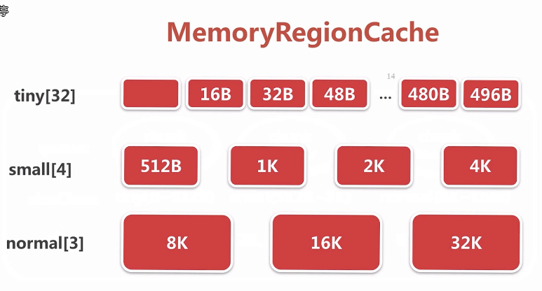

io.netty.buffer.PoolArena#numTinySubpagePools

//右移4位 相当于 除以 16  
static final int numTinySubpagePools = 512 >>> 4;//32

io.netty.buffer.PoolThreadCache#PoolThreadCache

final class PoolThreadCache {  
  
 private static final InternalLogger logger = InternalLoggerFactory.getInstance(PoolThreadCache.class);  
   
 //Arena 竞技场 直接开辟一块内存  
 final PoolArena<byte[]> heapArena;  
 final PoolArena<ByteBuffer> directArena;  
  
 // Hold the caches for the different size classes, which are tiny, small and normal.  
 //缓存一块连续内存  
 private final MemoryRegionCache<byte[]>[] tinySubPageHeapCaches;  
 private final MemoryRegionCache<byte[]>[] smallSubPageHeapCaches;  
 private final MemoryRegionCache<ByteBuffer>[] tinySubPageDirectCaches;  
 private final MemoryRegionCache<ByteBuffer>[] smallSubPageDirectCaches;  
 private final MemoryRegionCache<byte[]>[] normalHeapCaches;  
 private final MemoryRegionCache<ByteBuffer>[] normalDirectCaches;  
 ...  
}

tinySubPageDirectCaches = createSubPageCaches(  
 tinyCacheSize, PoolArena.numTinySubpagePools, SizeClass.Tiny);

小结：每一个线程中维护一个PoolThreadCache，PoolThreadCache会维护三种内存规格大小的cache，每种规格的cache又进行细分，其数组中的每一个元素都维持缓存队列，即MemoryRegionCache。

##### 7.11 命中缓存的分配流程

* 找到对应size的MemoryRegionCache
* 从queue中弹出一个entry给ByteBuf初始化
* 将弹出的entry扔到对象池中进行复用
  + 通过Recycle回收，减少GC，减少对象重复的创建与销毁

内存分配的入口：

io.netty.buffer.PoolArena#allocate(io.netty.buffer.PoolThreadCache, io.netty.buffer.PooledByteBuf, int)

// capacity < pageSize  
 boolean isTinyOrSmall(int normCapacity) {  
 return (normCapacity & subpageOverflowMask) == 0;  
 }  
  
 // normCapacity < 512  
 static boolean isTiny(int normCapacity) {  
 return (normCapacity & 0xFFFFFE00) == 0;  
 }  
  
 private void allocate(PoolThreadCache cache, PooledByteBuf<T> buf, final int reqCapacity) {  
 final int normCapacity = normalizeCapacity(reqCapacity);  
 if (isTinyOrSmall(normCapacity)) { // capacity < pageSize  
 int tableIdx;  
 PoolSubpage<T>[] table;  
 boolean tiny = isTiny(normCapacity);  
 if (tiny) { // < 512  
 //第一种  
 if (cache.allocateTiny(this, buf, reqCapacity, normCapacity)) {  
 // was able to allocate out of the cache so move on  
 return;  
 }  
 tableIdx = tinyIdx(normCapacity);  
 table = tinySubpagePools;  
 } else {  
 //第二种  
 if (cache.allocateSmall(this, buf, reqCapacity, normCapacity)) {  
 // was able to allocate out of the cache so move on  
 return;  
 }  
 tableIdx = smallIdx(normCapacity);  
 table = smallSubpagePools;  
 }  
  
 final PoolSubpage<T> head = table[tableIdx];  
  
 synchronized (head) {  
 final PoolSubpage<T> s = head.next;  
 if (s != head) {  
 assert s.doNotDestroy && s.elemSize == normCapacity;  
 long handle = s.allocate();  
 assert handle >= 0;  
 s.chunk.initBufWithSubpage(buf, handle, reqCapacity);  
  
 if (tiny) {  
 allocationsTiny.increment();  
 } else {  
 allocationsSmall.increment();  
 }  
 return;  
 }  
 }  
 allocateNormal(buf, reqCapacity, normCapacity);  
 return;  
 }  
 if (normCapacity <= chunkSize) {  
 //第三种  
 if (cache.allocateNormal(this, buf, reqCapacity, normCapacity)) {  
 // was able to allocate out of the cache so move on  
 return;  
 }  
 allocateNormal(buf, reqCapacity, normCapacity);  
 } else {  
 // Huge allocations are never served via the cache so just call allocateHuge  
 allocateHuge(buf, reqCapacity);  
 }  
 }

io.netty.buffer.PoolThreadCache.MemoryRegionCache#allocate

public final boolean allocate(PooledByteBuf<T> buf, int reqCapacity) {  
 Entry<T> entry = queue.poll();  
 if (entry == null) {  
 return false;  
 }  
 initBuf(entry.chunk, entry.handle, buf, reqCapacity);  
 entry.recycle();  
  
 // allocations is not thread-safe which is fine as this is only called from the same thread all time.  
 ++ allocations;  
 return true;  
}

io.netty.util.Recycler.DefaultHandle#recycle

public void recycle(Object object) {  
 if (object != value) {  
 throw new IllegalArgumentException("object does not belong to handle");  
 }  
 stack.push(this);  
}

##### 7.12 Arena、Chunk、Page、Subpage概念

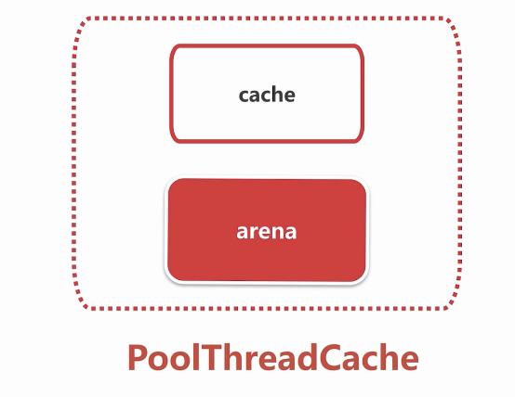

**Arena数据结构：**

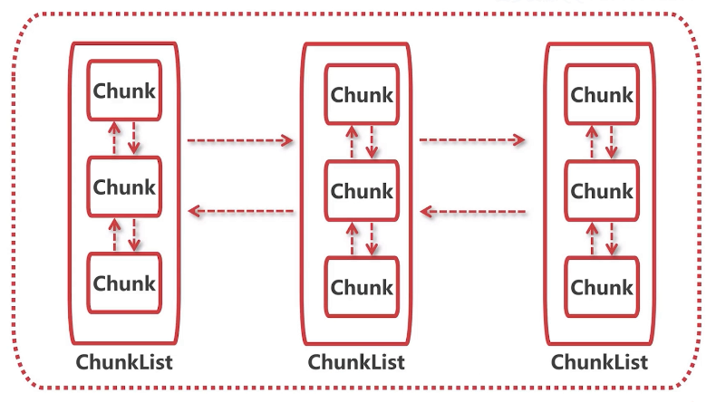

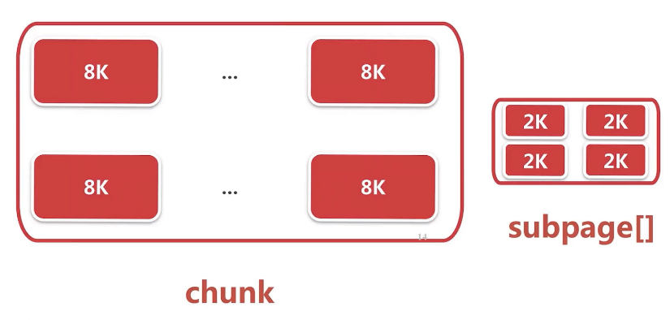

abstract class PoolArena<T> implements PoolArenaMetric {  
 static final boolean HAS_UNSAFE = PlatformDependent.hasUnsafe();  
  
 enum SizeClass {  
 Tiny,  
 Small,  
 Normal  
 }  
  
 static final int numTinySubpagePools = 512 >>> 4;  
  
 final PooledByteBufAllocator parent;  
  
 private final int maxOrder;  
 final int pageSize;  
 final int pageShifts;  
 final int chunkSize;  
 final int subpageOverflowMask;  
 final int numSmallSubpagePools;  
 private final PoolSubpage<T>[] tinySubpagePools;  
 private final PoolSubpage<T>[] smallSubpagePools;  
  
 private final PoolChunkList<T> q050;  
 private final PoolChunkList<T> q025;  
 private final PoolChunkList<T> q000;  
 private final PoolChunkList<T> qInit;  
 private final PoolChunkList<T> q075;  
 private final PoolChunkList<T> q100;  
 ...  
}

//PoolSubpage 数据结构 双向链表  
final class PoolSubpage<T> implements PoolSubpageMetric {  
 ...  
 PoolSubpage<T> prev;  
 PoolSubpage<T> next;  
 ...  
}

内存分配的流程：

从一个线程的PoolThreadCache中获取对应的Arena，Arena再通过PoolChunkList里面去一个chunk，

chunk会判断内存分配大小：

超过1个page，则以page为单位；若远小于一个page，则将一个page切分成多个子page进行内存划分。

##### 7.13 page 级别内存分配 allocateNormal()

* 尝试在现有的chunk上分配
* 创建一个chunk进行内存分配
* 初始化pooledByteBuf
* 一个chunk最终是以K为单位组织内存的，chunk中的每一个节点可以标识对应的这块内存是否被使用
* 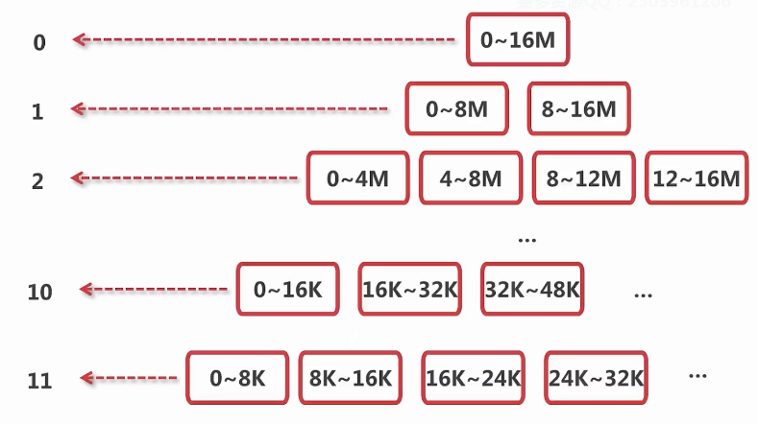

io.netty.buffer.PoolArena#allocateNormal

private synchronized void allocateNormal(PooledByteBuf<T> buf, int reqCapacity, int normCapacity) {  
 if (q050.allocate(buf, reqCapacity, normCapacity) || q025.allocate(buf, reqCapacity, normCapacity) ||  
 q000.allocate(buf, reqCapacity, normCapacity) || qInit.allocate(buf, reqCapacity, normCapacity) ||  
 q075.allocate(buf, reqCapacity, normCapacity)) {  
 ++allocationsNormal;  
 return;  
 }  
  
 // Add a new chunk.  
 PoolChunk<T> c = newChunk(pageSize, maxOrder, pageShifts, chunkSize);  
 long handle = c.allocate(normCapacity);  
 ++allocationsNormal;  
 assert handle > 0;  
 c.initBuf(buf, handle, reqCapacity);  
 qInit.add(c);  
}

##### 7.14 subpage 级别的内存分配 allocateTiny()

* 定位一个Subpage对象
* 初始化Subpage
* 初始化PooledByteBuf

io.netty.buffer.PoolChunk#allocateSubpage

private long allocateSubpage(int normCapacity) {  
 // Obtain the head of the PoolSubPage pool that is owned by the PoolArena and synchronize on it.  
 // This is need as we may add it back and so alter the linked-list structure.  
 PoolSubpage<T> head = arena.findSubpagePoolHead(normCapacity);  
 synchronized (head) {  
 int d = maxOrder; // subpages are only be allocated from pages i.e., leaves  
 int id = allocateNode(d);  
 if (id < 0) {  
 return id;  
 }  
  
 final PoolSubpage<T>[] subpages = this.subpages;  
 final int pageSize = this.pageSize;  
  
 freeBytes -= pageSize;  
  
 int subpageIdx = subpageIdx(id);  
 PoolSubpage<T> subpage = subpages[subpageIdx];  
 if (subpage == null) {  
 subpage = new PoolSubpage<T>(head, this, id, runOffset(id), pageSize, normCapacity);  
 subpages[subpageIdx] = subpage;  
 } else {  
 subpage.init(head, normCapacity);  
 }  
 return subpage.allocate();  
 }  
}

io.netty.buffer.PoolSubpage#init

PoolSubpage(PoolSubpage<T> head, PoolChunk<T> chunk, int memoryMapIdx, int runOffset, int pageSize, int elemSize) {  
 this.chunk = chunk;  
 this.memoryMapIdx = memoryMapIdx;  
 this.runOffset = runOffset;  
 this.pageSize = pageSize;  
 bitmap = new long[pageSize >>> 10]; // pageSize / 16 / 64  
 init(head, elemSize);  
}  
  
void init(PoolSubpage<T> head, int elemSize) {  
 doNotDestroy = true;  
 this.elemSize = elemSize;  
 if (elemSize != 0) {  
 maxNumElems = numAvail = pageSize / elemSize;  
 nextAvail = 0;  
 bitmapLength = maxNumElems >>> 6;  
 if ((maxNumElems & 63) != 0) {  
 bitmapLength ++;  
 }  
  
 for (int i = 0; i < bitmapLength; i ++) {  
 bitmap[i] = 0;//标识哪个子page已经被分配  
 }  
 }  
 addToPool(head);  
}

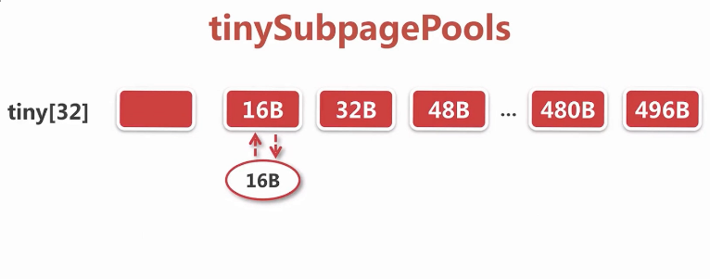

**chunk中的subpages**

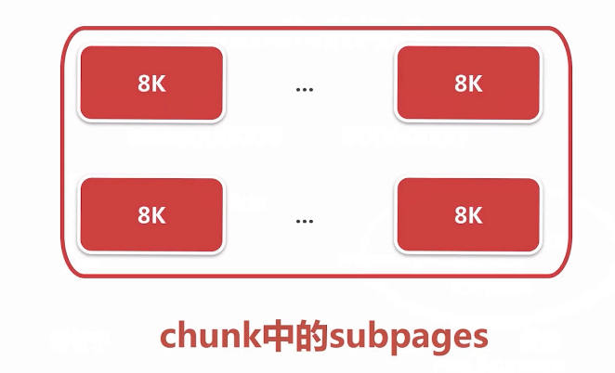

io.netty.buffer.PoolSubpage#allocate

//从位图中找到一个未被使用的subpage  
long allocate() {  
 if (elemSize == 0) {  
 return toHandle(0);  
 }  
  
 if (numAvail == 0 || !doNotDestroy) {  
 return -1;  
 }  
  
 final int bitmapIdx = getNextAvail();  
 int q = bitmapIdx >>> 6;  
 int r = bitmapIdx & 63;  
 assert (bitmap[q] >>> r & 1) == 0;  
 bitmap[q] |= 1L << r;  
  
 if (-- numAvail == 0) {  
 removeFromPool();  
 }  
 return toHandle(bitmapIdx);  
}

io.netty.buffer.PoolSubpage#toHandle

private long toHandle(int bitmapIdx) {  
 return 0x4000000000000000L | (long) bitmapIdx << 32 | memoryMapIdx;  
}

Handle的构成**

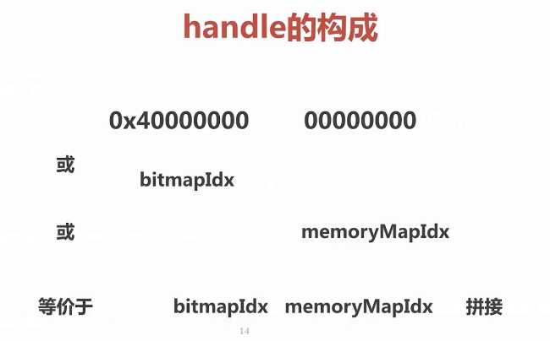

io.netty.buffer.PoolChunk#initBufWithSubpage(io.netty.buffer.PooledByteBuf, long, int, int)

private void initBufWithSubpage(PooledByteBuf<T> buf, long handle, int bitmapIdx, int reqCapacity) {  
 assert bitmapIdx != 0;  
  
 int memoryMapIdx = memoryMapIdx(handle);  
  
 PoolSubpage<T> subpage = subpages[subpageIdx(memoryMapIdx)];  
 assert subpage.doNotDestroy;  
 assert reqCapacity <= subpage.elemSize;  
  
 buf.init(  
 this, handle,  
 //page的偏移量 + subpage的偏移量 = 整个内存的偏移量 再给到bytebuf，  
 //这样bytebuf就可以基于这个偏移量进行读写  
 runOffset(memoryMapIdx) + (bitmapIdx & 0x3FFFFFFF) * subpage.elemSize, reqCapacity, subpage.elemSize,  
 arena.parent.threadCache());  
}

##### 7.15 ByteBuf的回收

public class AllocatorDemo {  
 public static void main(String[] args) {  
 PooledByteBufAllocator allocator = PooledByteBufAllocator.DEFAULT;  
 //申请一块内存  
 ByteBuf byteBuf = allocator.directBuffer(16);  
 //释放内存  
 byteBuf.release();  
 }  
}

io.netty.buffer.AbstractReferenceCountedByteBuf#release()

public boolean release() {  
 return release0(1);  
}

io.netty.buffer.PooledByteBuf#deallocate

protected final void deallocate() {  
 if (handle >= 0) {  
 final long handle = this.handle;  
 this.handle = -1;  
 memory = null;  
 chunk.arena.free(chunk, handle, maxLength, cache);  
 recycle();  
 }  
}

**ByteBuf的释放分析：**

* 连续的内存区段加到缓存
* io.netty.buffer.PoolThreadCache#cache(io.netty.buffer.PoolArena<?>, int, io.netty.buffer.PoolArena.SizeClass)
* boolean add(PoolArena<?> area, PoolChunk chunk, long handle, int normCapacity, SizeClass sizeClass) {  
   MemoryRegionCache<?> cache = cache(area, normCapacity, sizeClass);  
   if (cache == null) {  
   return false;  
   }  
   return cache.add(chunk, handle);  
  }  
    
    
  private MemoryRegionCache<?> cache(PoolArena<?> area, int normCapacity, SizeClass sizeClass) {  
   switch (sizeClass) {  
   case Normal:  
   return cacheForNormal(area, normCapacity);  
   case Small:  
   return cacheForSmall(area, normCapacity);  
   case Tiny:  
   return cacheForTiny(area, normCapacity);  
   default:  
   throw new Error();  
   }  
  }
* io.netty.buffer.PoolThreadCache.MemoryRegionCache#add
* public final boolean add(PoolChunk<T> chunk, long handle) {  
   Entry<T> entry = newEntry(chunk, handle);  
   boolean queued = queue.offer(entry);  
   if (!queued) {  
   // If it was not possible to cache the chunk, immediately recycle the entry  
   entry.recycle();  
   }  
   return queued;  
  }
* 标记连续的内存区段为未使用
  + page级别
  + subPage级别
* io.netty.buffer.PoolChunkList#free
* boolean free(PoolChunk<T> chunk, long handle) {  
   chunk.free(handle);  
   if (chunk.usage() < minUsage) {  
   remove(chunk);  
   // Move the PoolChunk down the PoolChunkList linked-list.  
   return move0(chunk);  
   }  
   return true;  
  }
* io.netty.buffer.PoolChunk#free
* void free(long handle) {  
   int memoryMapIdx = memoryMapIdx(handle);  
   int bitmapIdx = bitmapIdx(handle);  
    
   if (bitmapIdx != 0) { // free a subpage  
   PoolSubpage<T> subpage = subpages[subpageIdx(memoryMapIdx)];  
   assert subpage != null && subpage.doNotDestroy;  
    
   // Obtain the head of the PoolSubPage pool that is owned by the PoolArena and synchronize on it.  
   // This is need as we may add it back and so alter the linked-list structure.  
   PoolSubpage<T> head = arena.findSubpagePoolHead(subpage.elemSize);  
   synchronized (head) {  
   if (subpage.free(head, bitmapIdx & 0x3FFFFFFF)) {  
   return;  
   }  
   }  
   }  
   freeBytes += runLength(memoryMapIdx);  
   setValue(memoryMapIdx, depth(memoryMapIdx));  
   updateParentsFree(memoryMapIdx);  
  }
* ByteBuf加到对象池
* bytebuf可能会经常被申请和释放，如果qps高的时候可能会产生很多的bytebuf对象，为了尽可能的减少GC，netty使用对象池技术，当申请byteBuf的时候尽可能从对象池中取，当释放byteBuf的时候，将其放到对象池中。

##### 7.16 ByteBuf 总结

* ByteBuf的api和分类
* 分配pooled内存的总步骤
* 不同规格的pooled内存分配与释放

#### 八. Netty 解码

解码：把一串二级制数据流解析成一个个自定义的数据包即Bytebuf，后续业务处理都基于bytebuf。

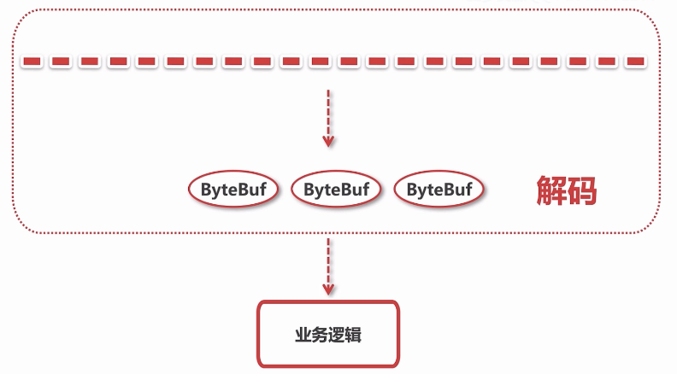

##### 8.1 .1思考问题

* 解码器抽象的解码过程
* netty中有哪些拆箱即用的解码器

##### 8.1.2 本章内容

* 解码器基类实现抽象解码的过程
* netty中常见的解码器分析

##### 8.2 解码器的基类 - ByteToMessageDecoder解码步骤

暴漏decode抽象方法，具体实现交给子类。好处是：不同的子类的协议可以有自定义的decode方法，而最外层解码的框架都是一致的。

* 累加字节流
* 调用子类的decode方法进行解析
* 将解析到的ByteBuf向下传播

io.netty.handler.codec.ByteToMessageDecoder#channelRead

public void channelRead(ChannelHandlerContext ctx, Object msg) throws Exception {  
 if (msg instanceof ByteBuf) {  
 CodecOutputList out = CodecOutputList.newInstance();  
 try {  
 ByteBuf data = (ByteBuf) msg;  
 first = cumulation == null;  
 if (first) {  
 cumulation = data;  
 } else {  
 //当前累加器里的数据和读进来数据进行累加 - 注意累加器的扩容逻辑  
 cumulation = cumulator.cumulate(ctx.alloc(), cumulation, data);  
 }  
 // out 用来接收从cumulation中解析到的对象  
 callDecode(ctx, cumulation, out);  
 } catch (DecoderException e) {  
 throw e;  
 } catch (Throwable t) {  
 throw new DecoderException(t);  
 } finally {  
 if (cumulation != null && !cumulation.isReadable()) {  
 numReads = 0;  
 cumulation.release();  
 cumulation = null;  
 } else if (++ numReads >= discardAfterReads) {  
 // We did enough reads already try to discard some bytes so we not risk to see a OOME.  
 // See https://github.com/netty/netty/issues/4275  
 numReads = 0;  
 discardSomeReadBytes();  
 }  
  
 int size = out.size();  
 decodeWasNull = !out.insertSinceRecycled();  
 // 讲解析到的对象向下传播到业务解码器  
 fireChannelRead(ctx, out, size);  
 out.recycle();  
 }  
 } else {  
 ctx.fireChannelRead(msg);  
 }  
}

io.netty.handler.codec.ByteToMessageDecoder#callDecode

protected void callDecode(ChannelHandlerContext ctx, ByteBuf in, List<Object> out) {  
 try {  
 while (in.isReadable()) {  
 int outSize = out.size();  
  
 if (outSize > 0) {  
 fireChannelRead(ctx, out, outSize);  
 out.clear();  
  
 // Check if this handler was removed before continuing with decoding.  
 // If it was removed, it is not safe to continue to operate on the buffer.  
 //  
 // See:  
 // - https://github.com/netty/netty/issues/4635  
 if (ctx.isRemoved()) {  
 break;  
 }  
 outSize = 0;  
 }  
  
 int oldInputLength = in.readableBytes();  
 decode(ctx, in, out);  
  
 // Check if this handler was removed before continuing the loop.  
 // If it was removed, it is not safe to continue to operate on the buffer.  
 //  
 // See https://github.com/netty/netty/issues/1664  
 if (ctx.isRemoved()) {  
 break;  
 }  
 //未解析到对象  
 if (outSize == out.size()) {  
 if (oldInputLength == in.readableBytes()) {  
 break;  
 } else {  
 continue;  
 }  
 }  
 if (oldInputLength == in.readableBytes()) {  
 throw new DecoderException(  
 StringUtil.simpleClassName(getClass()) +  
 ".decode() did not read anything but decoded a message.");  
 }  
  
 if (isSingleDecode()) {  
 break;  
 }  
 }  
 } catch (DecoderException e) {  
 throw e;  
 } catch (Throwable cause) {  
 throw new DecoderException(cause);  
 }  
}

##### 8.3 基于固定长度解码器分析

io.netty.handler.codec.FixedLengthFrameDecoder

/**  
 * A decoder that splits the received {@link ByteBuf}s by the fixed number  
 * of bytes. For example, if you received the following four fragmented packets:  
 * <pre>  
 * +---+----+------+----+  
 * | A | BC | DEFG | HI |  
 * +---+----+------+----+  
 * </pre>  
 * A {@link FixedLengthFrameDecoder}{@code (3)} will decode them into the  
 * following three packets with the fixed length:  
 * <pre>  
 * +-----+-----+-----+  
 * | ABC | DEF | GHI |  
 * +-----+-----+-----+  
 * </pre>  
 */  
public class FixedLengthFrameDecoder extends ByteToMessageDecoder {  
  
 //按frameLength的长度为分割进行解析  
 private final int frameLength;  
  
 /**  
 * Creates a new instance.  
 *  
 * @param frameLength the length of the frame  
 */  
 public FixedLengthFrameDecoder(int frameLength) {  
 if (frameLength <= 0) {  
 throw new IllegalArgumentException(  
 "frameLength must be a positive integer: " + frameLength);  
 }  
 this.frameLength = frameLength;  
 }  
  
 @Override  
 protected final void decode(ChannelHandlerContext ctx, ByteBuf in, List<Object> out) throws Exception {  
 Object decoded = decode(ctx, in);  
 if (decoded != null) {  
 out.add(decoded);  
 }  
 }  
  
 /**  
 * Create a frame out of the {@link ByteBuf} and return it.  
 *  
 * @param ctx the {@link ChannelHandlerContext} which this {@link ByteToMessageDecoder} belongs to  
 * @param in the {@link ByteBuf} from which to read data  
 * @return frame the {@link ByteBuf} which represent the frame or {@code null} if no frame could  
 * be created.  
 */  
 protected Object decode(  
 @SuppressWarnings("UnusedParameters") ChannelHandlerContext ctx, ByteBuf in) throws Exception {  
 //当前累加器可读字节 < frameLength  
 if (in.readableBytes() < frameLength) {  
 return null;  
 } else {  
 //从当前累加器截取frameLength个字节进行解析  
 return in.readRetainedSlice(frameLength);  
 }  
 }  
}

##### 8.4 基于行解码器分析

io.netty.handler.codec.LineBasedFrameDecoder

发过来的字节流是以 \r \n 或直接以 \n 结尾的字节流，该解码器的功能就是以 换行符 为分割，将字节流解析成完整的数据包。

回车、换行的区别  
  
在Windows中：  
  
 ‘\r’ (回车)：即将光标回到当前行的行首(而不会换到下一行)，之后的输出会把之前的输出覆盖  
  
 ‘\n’ 换行，换到当前位置的下一位置，而不会回到行首；  
  
 Unix系统里，每行结尾只有“<换行>”，即"\n"；  
  
 Windows系统里面，每行结尾是“<回车><换行>”，即“\r\n”；  
  
 Mac系统里，每行结尾是“<回车>”，即"\r"；  
  
也就是：  
 Linux中遇到换行符("\n")会进行回车+换行的操作，回车符（“\r”）反而只会作为控制字符("^M")显示，不发生回车的操作。  
 而windows中要回车符+换行符("\r\n")才会回车+换行，缺少一个控制符或者顺序不对都不能正确的另起一行。

LineBasedFrameDecoder 支持两种格式的换行符；

以\n 结尾 eol指向 \n

若以 \r \n 结尾， 会把\r \n 当作整体作为换行符， eol指向 \r

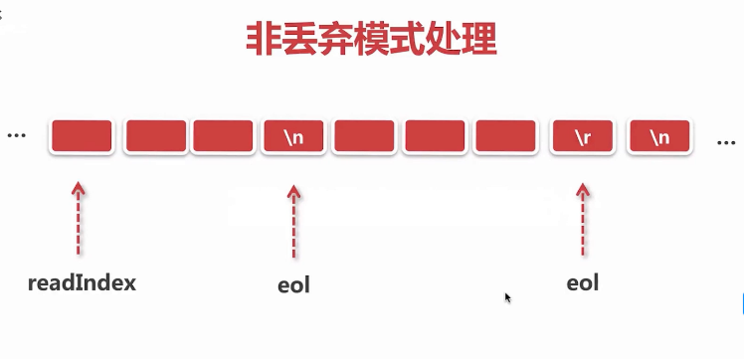

public class LineBasedFrameDecoder extends ByteToMessageDecoder {  
  
 /** Maximum length of a frame we're willing to decode.  
 能接收的最大字节  
 */  
 private final int maxLength;  
 /** Whether or not to throw an exception as soon as we exceed maxLength.  
 超过能接收的最大字节是否马上抛出异常  
 */  
 private final boolean failFast;  
 /**  
 最终解析出来的数据包是否带换行符，为true表示不带换行符  
 */  
 private final boolean stripDelimiter;  
  
 /** True if we're discarding input because we're already over maxLength. */  
 private boolean discarding;  
 private int discardedBytes;  
}  
  
  
......  
   
 protected final void decode(ChannelHandlerContext ctx, ByteBuf in, List<Object> out) throws Exception {  
 Object decoded = decode(ctx, in);  
 if (decoded != null) {  
 out.add(decoded);  
 }  
 }  
  
......  
   
 protected Object decode(ChannelHandlerContext ctx, ByteBuf buffer) throws Exception {  
 final int eol = findEndOfLine(buffer);  
 if (!discarding) {  
 if (eol >= 0) {  
 final ByteBuf frame;  
 final int length = eol - buffer.readerIndex();  
 final int delimLength = buffer.getByte(eol) == '\r'? 2 : 1;  
  
 if (length > maxLength) {  
 buffer.readerIndex(eol + delimLength);  
 fail(ctx, length);  
 return null;  
 }  
  
 if (stripDelimiter) {  
 frame = buffer.readRetainedSlice(length);  
 buffer.skipBytes(delimLength);  
 } else {  
 frame = buffer.readRetainedSlice(length + delimLength);  
 }  
  
 return frame;  
 } else {  
 final int length = buffer.readableBytes();  
 if (length > maxLength) {  
 discardedBytes = length;  
 buffer.readerIndex(buffer.writerIndex());  
 discarding = true;  
 if (failFast) {  
 fail(ctx, "over " + discardedBytes);  
 }  
 }  
 return null;  
 }  
 } else {  
 if (eol >= 0) {  
 final int length = discardedBytes + eol - buffer.readerIndex();  
 final int delimLength = buffer.getByte(eol) == '\r'? 2 : 1;  
 buffer.readerIndex(eol + delimLength);  
 discardedBytes = 0;  
 discarding = false;  
 if (!failFast) {  
 fail(ctx, length);  
 }  
 } else {  
 discardedBytes += buffer.readableBytes();  
 buffer.readerIndex(buffer.writerIndex());  
 }  
 return null;  
 }  
 }  
  
......  
   
 /**  
 * Returns the index in the buffer of the end of line found.  
 * Returns -1 if no end of line was found in the buffer.  
 */  
 private static int findEndOfLine(final ByteBuf buffer) {  
 int i = buffer.forEachByte(ByteProcessor.FIND_LF);  
 if (i > 0 && buffer.getByte(i - 1) == '\r') {  
 i--;  
 }  
 return i;  
 }

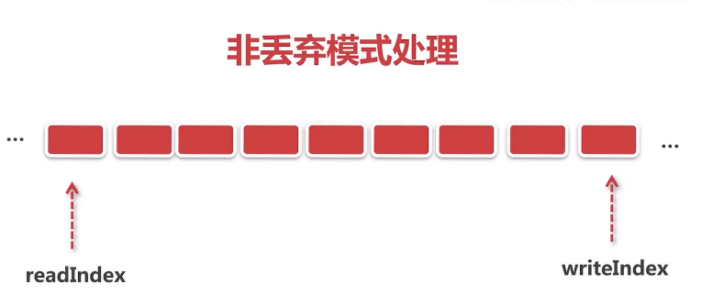

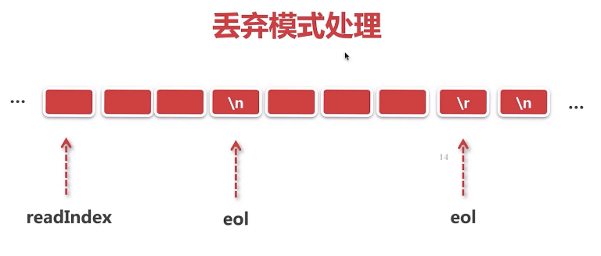

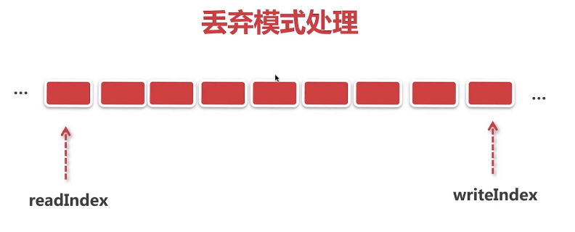

##### 8.5 基于固定分隔符解码器分析

* 行处理器
  + 若分隔符为换行符则直接使用行处理器
* 找到最小分隔符
* 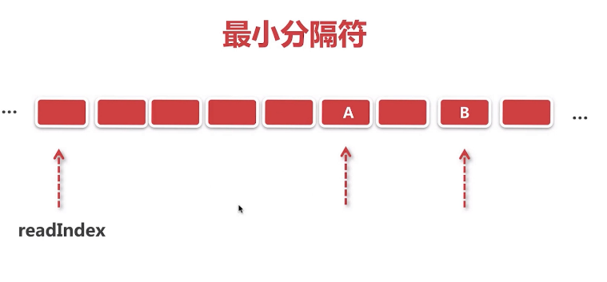
* 解码
* 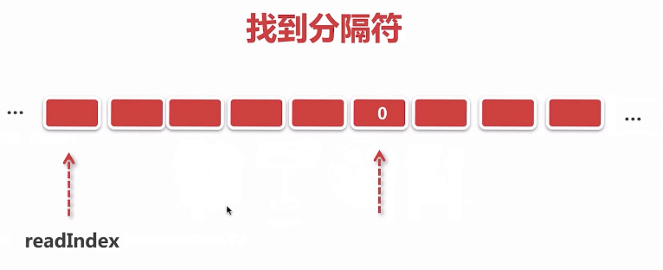

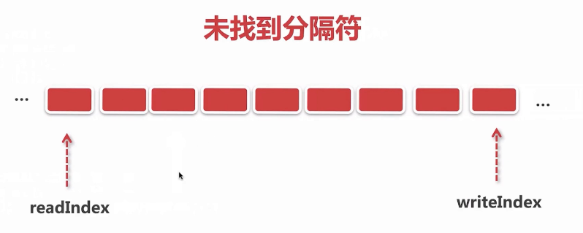

传进来的二进制字节流带有一系列的分隔符，经过这个解码器处理，可以分拆成一个个完整的数据包。

io.netty.handler.codec.DelimiterBasedFrameDecoder

protected Object decode(ChannelHandlerContext ctx, ByteBuf buffer) throws Exception {  
 if (lineBasedDecoder != null) {  
 return lineBasedDecoder.decode(ctx, buffer);  
 }  
 // Try all delimiters and choose the delimiter which yields the shortest frame.  
 int minFrameLength = Integer.MAX_VALUE;  
 ByteBuf minDelim = null;  
 for (ByteBuf delim: delimiters) {  
 int frameLength = indexOf(buffer, delim);  
 if (frameLength >= 0 && frameLength < minFrameLength) {  
 minFrameLength = frameLength;  
 minDelim = delim;  
 }  
 }  
  
 if (minDelim != null) {  
 int minDelimLength = minDelim.capacity();  
 ByteBuf frame;  
  
 if (discardingTooLongFrame) {  
 // We've just finished discarding a very large frame.  
 // Go back to the initial state.  
 discardingTooLongFrame = false;  
 buffer.skipBytes(minFrameLength + minDelimLength);  
  
 int tooLongFrameLength = this.tooLongFrameLength;  
 this.tooLongFrameLength = 0;  
 if (!failFast) {  
 fail(tooLongFrameLength);  
 }  
 return null;  
 }  
  
 if (minFrameLength > maxFrameLength) {  
 // Discard read frame.  
 buffer.skipBytes(minFrameLength + minDelimLength);  
 fail(minFrameLength);  
 return null;  
 }  
  
 if (stripDelimiter) {  
 frame = buffer.readRetainedSlice(minFrameLength);  
 buffer.skipBytes(minDelimLength);  
 } else {  
 frame = buffer.readRetainedSlice(minFrameLength + minDelimLength);  
 }  
  
 return frame;  
 } else {  
 if (!discardingTooLongFrame) {  
 if (buffer.readableBytes() > maxFrameLength) {  
 // Discard the content of the buffer until a delimiter is found.  
 tooLongFrameLength = buffer.readableBytes();  
 buffer.skipBytes(buffer.readableBytes());  
 discardingTooLongFrame = true;  
 if (failFast) {  
 fail(tooLongFrameLength);  
 }  
 }  
 } else {  
 // Still discarding the buffer since a delimiter is not found.  
 tooLongFrameLength += buffer.readableBytes();  
 buffer.skipBytes(buffer.readableBytes());  
 }  
 return null;  
 }  
}

##### 8.6 基于长度域解码器分析 - 最为常用

lengthFieldOffset:长度域在二进制数据流中的偏移量是多少

lengthFieldLength:从长度域开始往后的几个字节组合起来表表示长度

lengthAdjustment：

initialBytesToStrip：

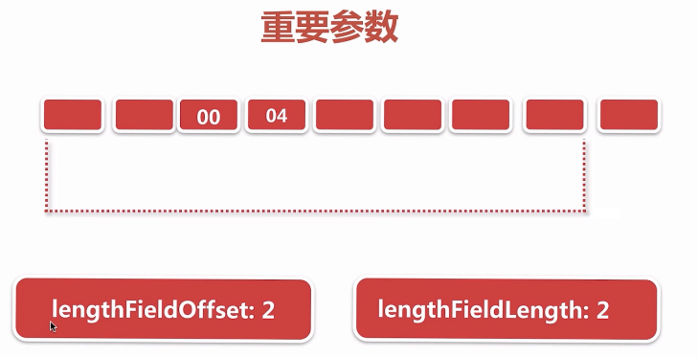

io.netty.handler.codec.LengthFieldBasedFrameDecoder

/**  
 * <b>lengthFieldOffset</b> = <b>0</b>  
 * <b>lengthFieldLength</b> = <b>2</b>  
 * lengthAdjustment = 0  
 * initialBytesToStrip = 0 (= do not strip header)  
 *  
 * BEFORE DECODE (14 bytes) AFTER DECODE (14 bytes)  
 * +--------+----------------+ +--------+----------------+  
 * | Length | Actual Content |----->| Length | Actual Content |  
 * | 0x000C | "HELLO, WORLD" | | 0x000C | "HELLO, WORLD" |  
 * +--------+----------------+ +--------+----------------+  
 * ......  
*/  
public class LengthFieldBasedFrameDecoder extends ByteToMessageDecoder {  
  
 private final ByteOrder byteOrder;  
 private final int maxFrameLength;  
 private final int lengthFieldOffset;  
 private final int lengthFieldLength;  
 private final int lengthFieldEndOffset;  
 private final int lengthAdjustment;  
 private final int initialBytesToStrip;  
 private final boolean failFast;  
 private boolean discardingTooLongFrame;  
 private long tooLongFrameLength;  
 private long bytesToDiscard;  
}

##### 8.7 基于长度域解码器步骤

* 计算要抽取的数据包长度
* 跳过字节逻辑处理
* 丢弃模式下的处理

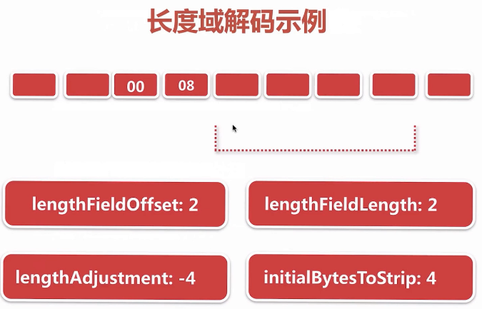

##### 8.8 解码器总结

#### 九. netty 编码

##### 9.1 问题：如何把对象变成字节流，最终写到socket底层

* encode() ——分别ByteBuf对象，encoder调用抽象的encode方法将接收到的数据填充到ByteBuf对象
* write() ——传递到Head节点，通过底层unsafe将当前的byteBuf塞到Unsafe底层维护的一个缓冲区对象中，同时计算写缓冲区数据是否超过高水位，若写缓冲区中可写的字计数 > 64 K, 就改变channel的状态为不可写
* flush() ——传递到Head节点，调用unsafe的flush方法，调整指针 -》通过for循环不断从写缓冲区拿byteBuf -》转化成JDK底层可以接收的ByteBuffer-》通过JDK的channel将byteBuffer写出去-》将写完一个将缓冲区中当前节点进行删除-》若写缓冲区中可写的字计数 < 32 K, 就改变channel的状态为可写

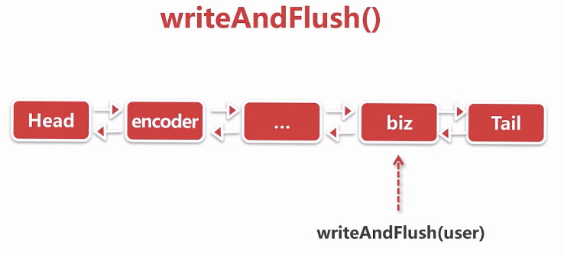

/**  
 * @Auther: leh  
 * @Date: 2019/11/15 15:55  
 * @Description: 将user对象编码  
 * ---------------------  
 * | 4 | 4 | ? |  
 * ---------------------  
 * | length | age | name |  
 * ---------------------  
 */  
public class Encoder extends MessageToByteEncoder<User> {  
 @Override  
 protected void encode(ChannelHandlerContext ctx, User user, ByteBuf out) throws Exception {  
 byte[] bytes = user.getName().getBytes();  
 out.writeInt(4 + bytes.length);  
 out.writeInt(user.getAge());  
 out.writeBytes(bytes);  
 }  
}

##### 9.2 writeAndFlush 抽象步骤

* 从tail节点开始往前传播
* 逐个调用channelHanler的write方法
* 逐个调用channelHandler的flush方法 - 真正写到底层去

public class BizHandler extends ChannelInboundHandlerAdapter {  
 @Override  
 public void channelRead(ChannelHandlerContext ctx, Object msg) throws Exception {  
 User user = new User(18, "zhangsan");  
 ctx.channel().writeAndFlush(user);  
 }  
}

io.netty.channel.AbstractChannelHandlerContext#writeAndFlush(java.lang.Object, io.netty.channel.ChannelPromise)

public ChannelFuture writeAndFlush(Object msg, ChannelPromise promise) {  
 if (msg == null) {  
 throw new NullPointerException("msg");  
 }  
  
 if (!validatePromise(promise, true)) {  
 ReferenceCountUtil.release(msg);  
 // cancelled  
 return promise;  
 }  
  
 write(msg, true, promise);  
  
 return promise;  
}  
  
...  
   
private void write(Object msg, boolean flush, ChannelPromise promise) {  
 AbstractChannelHandlerContext next = findContextOutbound();  
 final Object m = pipeline.touch(msg, next);  
 EventExecutor executor = next.executor();  
 if (executor.inEventLoop()) {  
 if (flush) {  
 next.invokeWriteAndFlush(m, promise);  
 } else {  
 next.invokeWrite(m, promise);  
 }  
 } else {  
 AbstractWriteTask task;  
 if (flush) {  
 task = WriteAndFlushTask.newInstance(next, m, promise);  
 } else {  
 task = WriteTask.newInstance(next, m, promise);  
 }  
 safeExecute(executor, task, promise, m);  
 }  
 }  
  
...  
   
 private void invokeWriteAndFlush(Object msg, ChannelPromise promise) {  
 if (invokeHandler()) {  
 invokeWrite0(msg, promise);  
 invokeFlush0();  
 } else {  
 writeAndFlush(msg, promise);  
 }  
 }  
  
...  
  
private void invokeWrite(Object msg, ChannelPromise promise) {  
 if (invokeHandler()) {  
 invokeWrite0(msg, promise);  
 } else {  
 write(msg, promise);  
 }  
 }

##### 9.3 抽象编码器处理逻辑 MessageToByteEncoder

将一个对象变成字节并写到socket底层。

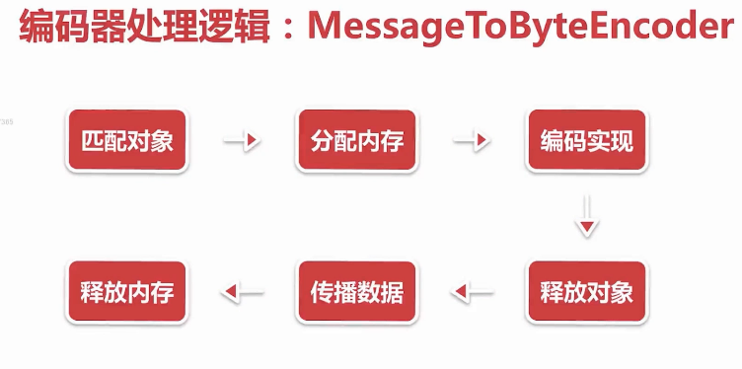

io.netty.handler.codec.MessageToByteEncoder#write

public void write(ChannelHandlerContext ctx, Object msg, ChannelPromise promise) throws Exception {  
 ByteBuf buf = null;  
 try {  
 //判断当前encoder处理器是否能处理这个对象  
 if (acceptOutboundMessage(msg)) {  
 @SuppressWarnings("unchecked")  
 I cast = (I) msg;  
 buf = allocateBuffer(ctx, cast, preferDirect);  
 try {  
 //最终会将转化后的对象填充到分配到的buf中  
 encode(ctx, cast, buf);  
 } finally {  
 //释放原始对象  
 ReferenceCountUtil.release(cast);  
 }  
  
 if (buf.isReadable()) {  
 //传播写好的数据直到Head节点  
 ctx.write(buf, promise);  
 } else {  
 buf.release();  
 ctx.write(Unpooled.EMPTY_BUFFER, promise);  
 }  
 buf = null;  
 } else {  
 ctx.write(msg, promise);  
 }  
 } catch (EncoderException e) {  
 throw e;  
 } catch (Throwable e) {  
 throw new EncoderException(e);  
 } finally {  
 if (buf != null) {  
 buf.release();  
 }  
 }  
}  
  
...  
   
protected ByteBuf allocateBuffer(ChannelHandlerContext ctx, @SuppressWarnings("unused") I msg,boolean preferDirect) throws Exception {  
 if (preferDirect) {  
 return ctx.alloc().ioBuffer();//分配堆外内存  
 } else {  
 return ctx.alloc().heapBuffer();//分配堆内内存  
 }  
 }

##### 9.4 写buffer队列

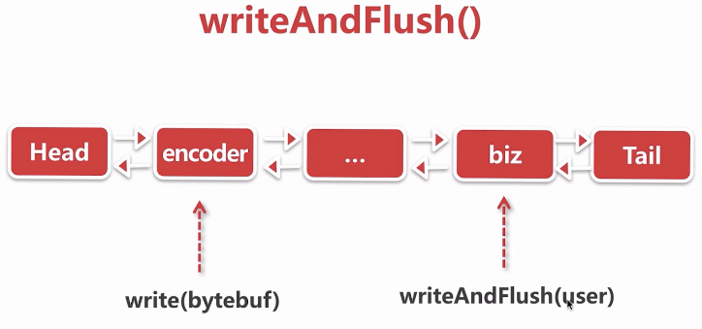

encoder将传进来的user对象转换成bytebuf传递到head节点，最终调用head节点的write方法

io.netty.channel.DefaultChannelPipeline.HeadContext#write

public void write(ChannelHandlerContext ctx, Object msg, ChannelPromise promise) throws Exception {  
 unsafe.write(msg, promise);  
}

io.netty.channel.AbstractChannel.AbstractUnsafe#write

public final void write(Object msg, ChannelPromise promise) {  
 assertEventLoop();  
  
 ChannelOutboundBuffer outboundBuffer = this.outboundBuffer;  
 if (outboundBuffer == null) {  
 // If the outboundBuffer is null we know the channel was closed and so  
 // need to fail the future right away. If it is not null the handling of the rest  
 // will be done in flush0()  
 // See https://github.com/netty/netty/issues/2362  
 safeSetFailure(promise, WRITE_CLOSED_CHANNEL_EXCEPTION);  
 // release message now to prevent resource-leak  
 ReferenceCountUtil.release(msg);  
 return;  
 }  
  
 int size;  
 try {  
 msg = filterOutboundMessage(msg);  
 size = pipeline.estimatorHandle().size(msg);  
 if (size < 0) {  
 size = 0;  
 }  
 } catch (Throwable t) {  
 safeSetFailure(promise, t);  
 ReferenceCountUtil.release(msg);  
 return;  
 }  
  
 outboundBuffer.addMessage(msg, size, promise);  
}

**write-写buffer队列**

* direct化ByteBuf
  + 将非堆外内存转化为堆外内存（零拷贝）
* io.netty.channel.nio.AbstractNioByteChannel#filterOutboundMessage
* protected final Object filterOutboundMessage(Object msg) {  
   if (msg instanceof ByteBuf) {  
   ByteBuf buf = (ByteBuf) msg;  
   if (buf.isDirect()) {  
   return msg;  
   }  
   return newDirectBuffer(buf);  
   }  
    
   if (msg instanceof FileRegion) {  
   return msg;  
   }  
   throw new UnsupportedOperationException(  
   "unsupported message type: " + StringUtil.simpleClassName(msg) + EXPECTED_TYPES);  
  }
* 插入写队列（写缓冲区 outBoundBuffer）
* io.netty.channel.ChannelOutboundBuffer#addMessage
* //三个指针  
  // Entry(flushedEntry) --> ... Entry(unflushedEntry) --> ... Entry(tailEntry)  
  //  
  // The Entry that is the first in the linked-list structure that was flushed  
  private Entry flushedEntry;  
  // The Entry which is the first unflushed in the linked-list structure  
  private Entry unflushedEntry;  
  // The Entry which represents the tail of the buffer  
  private Entry tailEntry;  
    
  ......  
    
  public void addMessage(Object msg, int size, ChannelPromise promise) {  
   Entry entry = Entry.newInstance(msg, size, total(msg), promise);  
   if (tailEntry == null) {  
   flushedEntry = null;  
   tailEntry = entry;  
   } else {  
   Entry tail = tailEntry;  
   tail.next = entry;  
   tailEntry = entry;  
   }  
   if (unflushedEntry == null) {  
   unflushedEntry = entry;  
   }  
    
   // increment pending bytes after adding message to the unflushed arrays.  
   // See https://github.com/netty/netty/issues/1619  
   incrementPendingOutboundBytes(size, false);  
  }
* 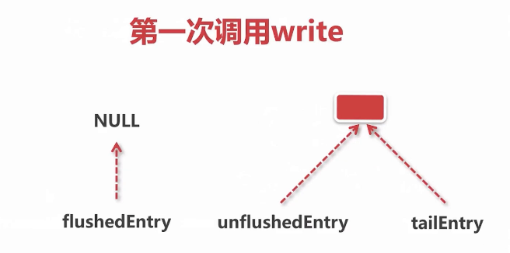
* 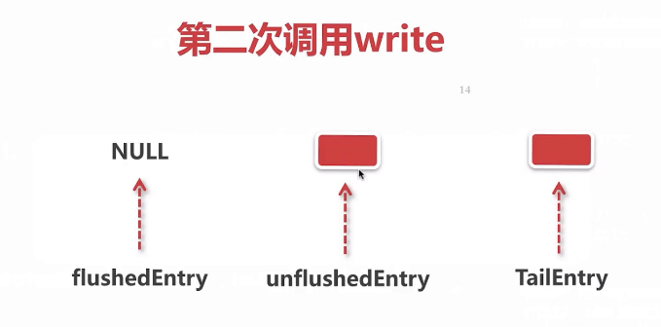
* 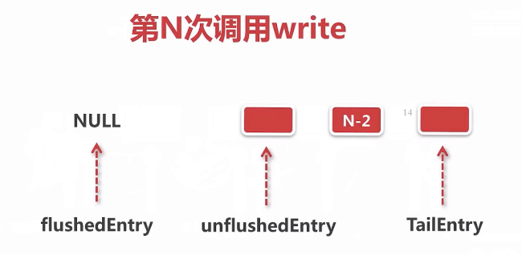
* 设置写状态
  + 若写缓冲区中的数据 > 默认的高水位 64k 就设置当前的channel为不可写状态
* io.netty.channel.ChannelOutboundBuffer#incrementPendingOutboundBytes(long, boolean)
* private void incrementPendingOutboundBytes(long size, boolean invokeLater) {  
   if (size == 0) {  
   return;  
   }  
    
   long newWriteBufferSize = TOTAL_PENDING_SIZE_UPDATER.addAndGet(this, size);  
   if (newWriteBufferSize > channel.config().getWriteBufferHighWaterMark()) {  
   setUnwritable(invokeLater);  
   }  
  }  
    
  ...  
     
  // 自旋 + CAS  
  private void setUnwritable(boolean invokeLater) {  
   for (;;) {  
   final int oldValue = unwritable;  
   final int newValue = oldValue | 1;  
   if (UNWRITABLE_UPDATER.compareAndSet(this, oldValue, newValue)) {  
   if (oldValue == 0 && newValue != 0) {  
   fireChannelWritabilityChanged(invokeLater);  
   }  
   break;  
   }  
   }  
   }

##### 9.5 刷新buffer队列

**flush - 刷新buffer队列** 将缓存区中的数据写入socket通道

* 添加刷新标志并设置写状态
  + 移动三个指针
  + 若写缓冲区中的数据 < 默认的低水位 32k 就设置当前的channel为可写状态
* 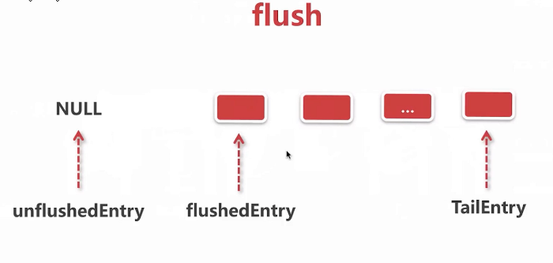
* 遍历buffer队列，过滤ByteBuf
* 调用jdk底层的API进行自选写

io.netty.channel.DefaultChannelPipeline.HeadContext#flush

public void flush(ChannelHandlerContext ctx) throws Exception {  
 unsafe.flush();  
}

io.netty.channel.AbstractChannel.AbstractUnsafe#flush

public final void flush() {  
 assertEventLoop();  
  
 ChannelOutboundBuffer outboundBuffer = this.outboundBuffer;  
 if (outboundBuffer == null) {  
 return;  
 }  
 outboundBuffer.addFlush();  
 flush0();  
}

io.netty.channel.ChannelOutboundBuffer#decrementPendingOutboundBytes(long, boolean, boolean)

private void decrementPendingOutboundBytes(long size, boolean invokeLater, boolean notifyWritability) {  
 if (size == 0) {  
 return;  
 }  
 long newWriteBufferSize = TOTAL_PENDING_SIZE_UPDATER.addAndGet(this, -size);  
 if (notifyWritability && newWriteBufferSize < channel.config().getWriteBufferLowWaterMark()) {  
 setWritable(invokeLater);  
 }  
}

io.netty.channel.DefaultChannelConfig#writeBufferWaterMark

private volatile WriteBufferWaterMark writeBufferWaterMark = WriteBufferWaterMark.DEFAULT;

io.netty.channel.WriteBufferWaterMark

public final class WriteBufferWaterMark {  
  
 private static final int DEFAULT_LOW_WATER_MARK = 32 * 1024;  
 private static final int DEFAULT_HIGH_WATER_MARK = 64 * 1024;  
  
 public static final WriteBufferWaterMark DEFAULT =  
 new WriteBufferWaterMark(DEFAULT_LOW_WATER_MARK, DEFAULT_HIGH_WATER_MARK, false);  
  
 private final int low;  
 private final int high;  
 ...  
}

io.netty.channel.nio.AbstractNioByteChannel#doWrite

protected void doWrite(ChannelOutboundBuffer in) throws Exception {  
 int writeSpinCount = -1;  
  
 boolean setOpWrite = false;  
 for (;;) {  
 Object msg = in.current();  
 if (msg == null) {  
 // Wrote all messages.  
 clearOpWrite();  
 // Directly return here so incompleteWrite(...) is not called.  
 return;  
 }  
  
 if (msg instanceof ByteBuf) {  
 ByteBuf buf = (ByteBuf) msg;  
 int readableBytes = buf.readableBytes();  
 if (readableBytes == 0) {  
 in.remove();  
 continue;  
 }  
  
 boolean done = false;  
 long flushedAmount = 0;  
 if (writeSpinCount == -1) {  
 // 并发编程中使用自旋可以提高内存使用率和吞吐量  
 writeSpinCount = config().getWriteSpinCount();  
 }  
 for (int i = writeSpinCount - 1; i >= 0; i --) {  
 //将buf写到socket  
 int localFlushedAmount = doWriteBytes(buf);  
 if (localFlushedAmount == 0) {  
 setOpWrite = true;  
 break;  
 }  
  
 flushedAmount += localFlushedAmount;  
 if (!buf.isReadable()) {  
 done = true;  
 break;  
 }  
 }  
  
 in.progress(flushedAmount);  
  
 if (done) {  
 in.remove();  
 } else {  
 // Break the loop and so incompleteWrite(...) is called.  
 break;  
 }  
 } else if (msg instanceof FileRegion) {//认为是从磁盘读到socket  
 FileRegion region = (FileRegion) msg;  
 boolean done = region.transferred() >= region.count();  
 ...  
 } else {  
 // Should not reach here.  
 throw new Error();  
 }  
 }  
 incompleteWrite(setOpWrite);  
}

io.netty.channel.ChannelConfig#getWriteSpinCount

/**  
 自旋提高写的吞吐量，默认自旋16次  
 * Returns the maximum loop count for a write operation until  
 * {@link WritableByteChannel#write(ByteBuffer)} returns a non-zero value.  
 * It is similar to what a spin lock is used for in concurrency programming.  
 * It improves memory utilization and write throughput depending on  
 * the platform that JVM runs on. The default value is {@code 16}.  
 */  
int getWriteSpinCount();

io.netty.channel.socket.nio.NioSocketChannel#doWriteBytes

protected int doWriteBytes(ByteBuf buf) throws Exception {  
 final int expectedWrittenBytes = buf.readableBytes();  
 return buf.readBytes(javaChannel(), expectedWrittenBytes);  
}

io.netty.buffer.PooledDirectByteBuf#readBytes(java.nio.channels.GatheringByteChannel, int)

public int readBytes(GatheringByteChannel out, int length) throws IOException {  
 checkReadableBytes(length);  
 int readBytes = getBytes(readerIndex, out, length, true);  
 readerIndex += readBytes;  
 return readBytes;  
}

io.netty.buffer.PooledDirectByteBuf#getBytes(int, java.nio.channels.GatheringByteChannel, int, boolean)

// GatheringByteChannel 是 JDK底层的  
private int getBytes(int index, GatheringByteChannel out, int length, boolean internal) throws IOException {  
 checkIndex(index, length);  
 if (length == 0) {  
 return 0;  
 }  
  
 //JDK相关的ByteBUffer 将netty自定以的byteBuf塞到JDK的ByteBUffer  
 ByteBuffer tmpBuf;  
 if (internal) {  
 tmpBuf = internalNioBuffer();  
 } else {  
 tmpBuf = memory.duplicate();  
 }  
 index = idx(index);  
 tmpBuf.clear().position(index).limit(index + length);  
 // 调用JDK底层的write方法，将tmpBuf写到socket通道中，并返回写的字节数  
 return out.write(tmpBuf);  
}

##### 9.6 netty编码总结